The Real Story behind Story Problems:
Effects of Representations on Quantitative Reasoning

Kenneth R. Koedinger*
Carnegie Mellon University

Mitchell J. Nathan
University of Colorado

RUNNING HEAD: Story behind Story Problems

*Contact Information:

Ken Koedinger
Human-Computer Interaction Institute
Carnegie Mellon University
Pittsburgh, PA 15213
Phone: 412-268-7667
Fax: 412-268-1266
Email: koedinger@cmu.edu

Abstract
We explored how differences in problem representations change both the performance and underlying cognitive processes of beginning algebra students engaged in quantitative reasoning. Contrary to beliefs held by practitioners and researchers in mathematics education, we found that students were more successful solving simple algebra story problems than solving mathematically equivalent equations. Contrary to some views of situated cognition, this result is not simply a consequence of situated world knowledge facilitating problem solving performance, but rather a consequence of student difficulties with comprehending the formal symbolic representation of quantitative relations. We draw on analyses of students’ strategies and errors as the basis for a cognitive process explanation of when, why, and how differences in problem representation affect problem solving. In general, we conclude that differences in external representations can affect performance and learning when one representation is easier to comprehend than another or when one representation elicits more reliable and meaningful solution strategies than another.

Key words: problem solving, knowledge representation, mathematics learning, cognitive processes, complex skill acquisition

Introduction

Story Problems Are Believed to Be Difficult
A commonly held belief about story problems at both the arithmetic and algebra levels is that they are notoriously difficult for students. Support for this belief can be seen among a variety of populations including the general public, textbook authors, teachers, mathematics education researchers, and learning science researchers. For evidence that this belief is commonly held within the general public, ask your neighbor. More likely than not, he or she will express a sentiment toward story problems along the lines of Gary Larson’s cartoon captioned "Hell's Library" that contains book shelves full of titles like "Story Problems," "More Story Problems," and "Story Problems Galore." That many textbook authors believe in the greater difficulty of story problems is supported by an analysis of textbooks by Nathan, Long, and Alibali (2002). In 9 of the 10 textbooks they analyzed, new topics are initially presented through symbolic activities and only later are story problems presented, often as “challenge problems”. The choice of this ordering is consistent with the belief that symbolic representations are more accessible to students than story problems.
More direct evidence of the common belief in the difficulty of story problems comes from surveys of teachers and mathematics educators. In a survey of 67 high school mathematics teachers, Nathan & Koedinger (2000a) found that most predicted that story problems would be harder for algebra students than matched equations. Nathan & Koedinger (2000a) also surveyed 35 mathematics education researchers. The majority of these researchers also predicted that story problems would be harder for algebra students than matched equations. In another study of 105 K-12 mathematics teachers, Nathan & Koedinger (2000b) found that significantly more teachers agree than disagree with statements like “Solving math problems presented in words should be taught only after students master solving the same problems presented as equations.” This pattern was particularly strong among the high school teachers in the sample (n = 30).
Belief in the difficulty of story problems is also reflected in the learning science literature. Research on story problem solving, at both the arithmetic (Carpenter, Kepner, Corbitt, Lindquist, & Reys, 1980; Cummins et al., 1988; Kintsch & Greeno, 1985) and algebra levels (Clement, 1982; Nathan et al., 1992; Paige & Simon, 1966), has emphasized the difficulty of such problems. For instance, Cummins and her colleagues (1988, p. 405) commented "word problems are notoriously difficult to solve". They investigated first graders’ performance on matched problems in story and numeric format for 18 different categories of one operator arithmetic problems. Students were 27% correct on the “Compare 2” problem in story format: “Mary has 6 marbles. John has 2 marbles. How many marbles does John have less than Mary?” but were 100% correct on the matched numeric format problem, “6 - 2 = ?”. They found performance on story problems was worse than performance on matched problems in numeric format for 14 of the 18 categories and was equivalent for the remaining 4 categories. Belief in the greater difficulty of story problems is also evident in the broader developmental literature. For instance, Geary (1994, p. 96) states "children make more errors when solving word problems than when solving comparable number problems."
Although the research that Cummins and others (1988) performed and reviewed addressed elementary-level arithmetic problem solving, they went on to make the broader claim that "as students advance to more sophisticated domains, they continue to find word problems in those domains more difficult to solve than problems presented in symbolic format (e.g., algebraic equations)" (p. 405). However, apart from our own studies reported here, this broader claim appears to have remained untested (cf., Reed, 1998). We have not found prior experimental comparisons of solution correctness on matched algebra story problems and equations for students learning algebra. In a related study, Mayer (1982a) used solution times to make inferences about the different strategies that well-prepared college students use on algebra word and equation problems. He found a different profile of solution times for word problems than equations as problems varied in complexity and accounted for these differences by the hypothesis that students use a goal-based “isolate” strategy on equations and a less memory-intensive “reduce” strategy on word problems. Overall, students took significantly longer to solve 1-5 step word problems (about 15 seconds) than matched equations (about 5 seconds) with no reliable difference in number of errors (7% for word problems, 4% for equations). Whereas Mayer’s study focused on timing differences for well-practiced participants, the studies reported here focus on error differences for beginning algebra students.

Why are Story Problems Difficult?
What might account for the purported and observed difficulties of story problems? As many researchers have observed (Cummins et al., 1988; Hall et al., 1989; Lewis & Mayer, 1987; Mayer, 1982b), the process of story problem solving can be divided into a comprehension phase and a solution phase (see Figure 1). In the comprehension phase, problem solvers process the text of the story problem and create corresponding internal representations of the quantitative and situation-based relationships expressed in that text (Nathan, Kintsch, & Young, 1992). In the solution phase problem solvers use or transform the quantitative relationships that are represented both internally and externally to arrive at a solution. Two kinds of process explanations for the difficulty of story problems correspond with these two problem-solving phases. We will return to these explanations, but first we describe how these two phases interact during problem solving (for more detail see Koedinger & MacLaren, 2002).
----- Insert Figure 1 about here -----
In general, the comprehension and solution phases are typically interleaved rather than performed sequentially. Problem solvers iteratively comprehend first a small piece of the problem statement (e.g., a clause or sentence) and then produce a piece of corresponding external representation (e.g., an arithmetic operation or algebraic expression), often as an external memory aid. In Figure 1, the double-headed arrows within the larger arrows are intended to communicate this interactivity. During problem solving, aspects of newly constructed internal or external representations may influence further comprehension in later cycles (Kinstch, 1998). For example, after determining that the unknown value is the number of donuts, the reader may then search for and reread a clause that uses number of donuts in a quantitative relation. Similarly, the production of aspects of the external representation may help maintain internal problem-solving goals that, in turn, may direct further comprehension processes.
A number of researchers have provided convincing evidence that errors in the comprehension phase well account for story problem solving difficulties (e.g., Cummins et al., 1988; Lewis & Mayer, 1987). For instance, Cummins et al. (1988) demonstrated that variations in first graders’ story problem performance were well predicted by variations in problem recall and that both could be accounted for by difficulties students had in comprehending specific linguistic forms like “some”, “more X’s than Y’s”, and “altogether”. They concluded that “text comprehension factors figure heavily in word problem difficulty” (p. 435). Lewis and Mayer (1987) summarized past studies with K-6 graders and their own studies with college students showing more solution errors on arithmetic story problems with “inconsistent language” (e.g., when the problem says “more than”, but subtraction is required to solve it) than problems with consistent language. Teachers’ intuitions about the difficulty of algebra story problems (c.f., Nathan & Koedinger, 2000) appear to be in line with these investigations of comprehension difficulties with arithmetic story problems. As one teacher explained “students are used to expressions written algebraically and have typically had the most practice with these … translating ‘English’ or ‘non-mathematical’ words is a difficult task for many students”.
A second process explanation for the difficulty of story problems focuses on the solution phase and particularly on the strategies students use to process aspects of the problem. A common view of how story problems are or should be solved, particularly at the algebra level, is that the problem text is first translated into written symbolic form and then the symbolic problem is solved (e.g., see Figure 4a). If problem solvers use this translate-and-solve strategy, then clearly story problems will be harder than matched symbolic problems since solving the written symbolic problem is an intermediate step in this case.
At least at the algebra level, the translate-and-solve strategy has a long tradition as the recommended approach. Paige & Simon (1966) comment regarding an algebra-level story problem, “At a common-sense level, it seems plausible that a person solves such problems by, first, translating the problem sentences into algebraic equations and, second, solving the equations”. They go on to quote a 1929 textbook recommending this approach (Hawkes, Luby, Touton, 1929). Modern textbooks also recommend this approach, and typically present story problems as “challenge problems” and “applications” in the back of problem-solving sections (Nathan et al., 2002). Thus, a plausible source for teachers’ belief in the difficulty of story problems over equations is the idea that equations are needed to solve story problems. An algebra teacher performing the problem-difficulty ranking task described in Nathan & Koedinger (2000a) made the following reference to the translate-and-solve strategy (the numbers 1-6 refer to sample problems teachers were given which were the same as those in Table 1):
“1 [the arithmetic equation] would be a very familiar problem… Same for 4 [the algebra equation] … 3 [the arithmetic story] and 6 [the algebra story]) add context … Students would probably write 1 or 4 [equations] from any of the others before proceeding.”

Story Problems Can be Easier
In contrast to the common belief that story problems are more difficult than matched equations, some studies have identified circumstances where story problems are easier to solve than equations. Carraher, Carraher, & Schliemann (1987) found that Brazilian third graders were much more successful solving story problems (e.g., "Each pencil costs $.03. I want 40 pencils. How much do I have to pay?") than solving matched problems presented symbolically (e.g., "3 x 40"). Baranes, Perry & Stigler (1989) used the same materials with US third graders. US children had higher overall success than the Brazilian children and, unlike the Brazilian children, did not perform better in general on story problems than symbolic problems. However, Baranes and colleagues (1989) demonstrated specific conditions under which the US children did perform better on story problems than symbolic ones, namely, money contexts and numbers involving multiples of 25, corresponding to the familiar value of a quarter of a dollar.
If story problems are sometimes easier as the Carraher and colleagues (1987) and Baranes and colleagues (1989) results suggest, what is it about the story problem representation that can enhance student performance? Baranes and colleagues (1989) hypothesized that the situational context of story problems can make them easier than equivalent symbolic problems. In particular, they suggested that the problem situation activates real-world knowledge (“culturally constituted systems of quantification”, p. 316) that aids students in arriving at a correct solution.
Such an advantage of stories over symbolic forms can be explained within the solution phase of the problem-solving framework presented in Figure 1. Story problems can be easier when stories elicit different, more effective, solution strategies than those elicited by equations. Past studies have demonstrated that different strategies can be elicited even by small variations in phrasing of the same story. For example, Hudson (1983) found that nursery school children were 17% correct on a standard story phrasing “There are 5 birds and 3 worms. How many more birds are there than worms?” However, performance increased to an impressive 83% when the story is phrased as “There are 5 birds and 3 worms. How many birds don’t get a worm?” The latter phrasing elicits a match-and-count strategy that is more accessible for novice learners than the more sophisticated subtraction strategy elicited by the former, more standard phrasing.
The notion of a “situation model” (Kintsch & Greeno, 1985; Nathan et al., 1992) provides a theoretical account of how story problems described in one way can elicit different strategies than equations or story problems described in other ways. In this account, problem solvers comprehend the text of a story problem by constructing a model-based representation of actors and actions in the story. Differences in the stories tend to produce differences in the situation models, which in turn can influence the selection and execution of alternative solution strategies. By this account, it is the differences in these strategies, at the solution phase (see Figure 1) that ultimately accounts for differences in performance. For instance, Nunes, Schliemann, & Carraher (1993) found that everyday problems were more likely to evoke oral solution strategies whereas symbolic problems evoked less effective written arithmetic strategies.
Developers of process models of story problem solving (e.g., Bobrow, 1968; Cummins et al., 1988; Mayer, 1982b) have been careful to differentiate comprehension versus solution components of story problem solving. However, readers of the literature might be left with the impression that equation solving involves only a solution phase; in other words, that comprehension is not necessary. Although it may be tempting to think of “comprehension” as restricted to the processing of natural language, clearly other external forms, like equations, charts, and diagrams (cf., Larkin & Simon, 1987), must be understood or “comprehended” to be used effectively to facilitate reasoning. The lack of research on student comprehension of number sentences or equations may result from a belief that such processing is transparent or trivial for problem solvers at the algebra level. Regarding equations like “(81.90 - 66)/6 = x” and “x * 6 + 66 = 81.90” in Table 2, an algebra teacher commented that these could be solved “without thinking”.

Hypotheses and Experimental Design
The two studies presented here are the first we know of that test the common belief that algebra learners have greater difficulty with story problems than matched equations. Table 1 shows examples of the main factors manipulated in these studies. In addition to the main contrast between story problems and equations (first and last columns in Table 1), we added an intermediate problem representation we refer to as “word problems” or “word equations” (middle column in Table 1). We included word equations to isolate effects of situational knowledge from effects of differences in “language” comprehension demands between verbal and symbolic forms. If stories cue useful situational knowledge, then we should find students making fewer errors on story problems than both word and symbolic equations. If students’ relevant symbolic comprehension skills are lagging behind their relevant verbal comprehension skills, then we should find them making more errors on symbolic equations than either of the verbal forms.
----- Insert Table 1 about here -----
Our goal was to explore representation effects for students at the transition from arithmetic to algebraic competence - a domain referred to as “early algebra” (cf., Carpenter & Levi, 1999; Kaput, in press). Thus, we included both relatively complex arithmetic problems (first row in Table 1) and relatively simple algebra problems (second row in Table 1). In the arithmetic problems, the problem unknown is the result of the process or sequence of operators described. These “result-unknown” problems are more complex than those used in prior research on elementary arithmetic problem solving (Briars & Larkin, 1984; Carpenter & Moser, 1984; Hiebert, 1982; Riley & Greeno, 1988). They involve two arithmetic operators (e.g., multiplication and addition) rather than one, decimals rather than just whole numbers, and more advanced symbolic notation like parentheses and equations with a variable on the right side (e.g., “(81.90 – 66)/6 = x”). The relatively simple algebra problems we used are two operator “start-unknowns”, that is problems where the unknown is at the start of the arithmetic process described.
These problems are not meant to be representative of all kinds of algebraic thinking or even all kinds of algebraic problem solving. As others have well noted (cf., Carpenter & Levi, 1999; Kaput, in press), algebraic thinking involves more than problem solving and includes study of functional relations, covariation, graph comprehension, mathematical modeling and symbolization, and pattern generalization. Even within the smaller area of algebraic problem solving, there is a large variety of problems. Others have explored more difficult classes of algebra problems than the ones used, for instance, problems where the unknown is referenced more than once and possibly on both sides of the equal sign, like “5.8x – 25 = 5.5x” (e.g., Bednarz & Janvier, 1996; Koedinger, Alibali, & Nathan, submitted; Kieran, 1992). Still others have begun to explore simpler classes of problems that may draw out algebraic thinking in elementary students (e.g., Carpenter & Levi, 1999; Carraher, Schliemann, & Brizuela, 2000).
----- Insert Table 2 about here -----
Our review of the literature on story problem solving leads us to consider three competing hypotheses regarding the effects of problem representation on quantitative problem solving at the early algebra level. The “symbolic facilitation” hypothesis is consistent with the common belief that equations should be easier than matched story problems because difficult English language comprehension demands are avoided (Cummins et al., 1988) and because the solution step of translating the problem statement to an equation is eliminated (Paige & Simon, 1966). The “situation facilitation” hypothesis follows from the idea that story representations can cue knowledge that facilitates effective strategy selection and execution (cf., Baranes et al., 1989; Carraher et al., 1987). Note that the four cover stories we used, shown in Table 2, all involve money quantities and familiar contexts for junior-high aged students. The situation facilitation hypothesis predicts that students will make fewer errors on story problems than on situation-free word-equations and equations.
A third “verbal facilitation” hypothesis follows from the observation that algebra equations are not transparently understood and the equation comprehension skills of beginning algebra students may lag behind their existing English language comprehension skills. The verbal facilitation hypothesis predicts that students will make fewer errors on story and word equations than on the more abstract equations. The verbal facilitation claim is similar to the situational facilitation and the culturally-bound results of Carraher et al. (1987) and Baranes et al. (1989) that in some cases situational knowledge helps elementary students perform better on story problems than matched equations. For algebra students, however, it is not just situation knowledge that can make story problems easier. Rather, it is also that the increased demands on symbolic comprehension presented by equations lead to difficulties for algebra students who have by now mostly mastered the English comprehension knowledge needed for matched verbally-stated problems. The verbal facilitation hypothesis uniquely predicts that both word equations and story problems can be easier than matched equations.
In contrast with the idea that equations are transparently understood, a key point of this article is to test the claim that comprehension of algebra equations is not trivial for algebra learners and that, as a consequence, algebra story problems can sometimes be easier to solve than matched equations. The verbal facilitation claim directly contradicts the documented views of many teachers and education researchers (Nathan & Koedinger, 2000a, 2000b) and cognitive scientists (e.g., Cummins et al., 1988; Geary, 1994) that algebra story problems are inherently more difficult than matched equations. This claim also addresses a gap in past theoretical analyses of quantitative reasoning that have provided models of story comprehension (e.g., Bobrow, 1968; Cummins et al., 1988; Kintsch & Greeno, 1985; Nathan, Kintsch, & Young, 1992) but have neglected equation comprehension. These models did not address the possibility that the equation format may present greater comprehension challenges for learners than analogous verbal forms (cf. Kirshner, 1989; Sleeman, 1984).

Difficulty Factors Assessments: Studies 1 and 2
We investigated the symbolic, situation, and verbal facilitation hypotheses in two studies. In both studies, students were asked to solve problems selected from a multi-dimensional space of problems systematically generated by crossing factors expected to influence the degree of difficulty of problems. In addition to the problem representation and unknown position factors shown in Table 1, we also manipulated the type of the numbers involved (whole number vs. positive decimals) and the final arithmetic that problems required (multiplication and addition vs. subtraction and division). We refer to the methodology we employ as “Difficulty Factors Assessment” or DFA (Heffernan & Koedinger, 1998; Koedinger & MacLaren, 2002; Koedinger & Tabachneck, 1993; Verzoni & Koedinger, 1997) and the two studies described here as DFA1 and DFA2.

Methods for DFA1 and DFA2

Subjects
The subjects in DFA1 were 76 students from an urban high school. Of these students, 58 were enrolled in one of 3 mainstream Algebra 1 classes, and 18, who took Algebra 1 in 8th grade, were 9th graders enrolled in a Geometry class. Four different teachers taught the classes. The subjects in DFA2 were 171 students sampled from 24 classrooms at three urban high schools. All students were in a first year Algebra 1 course. Twelve different teachers taught the 24 classroom sections.

Form design
Ninety-six problems were created using four different cover stories that systematically vary four difficulty factors: 3 levels of problem presentation (Story, word equation, and symbol equation) X 2 levels of unknown positions (result vs. start) X 2 number types (whole vs. decimal) X 2 final arithmetic types (multiplication and addition vs. subtraction and division). Table 3 shows the "cross table" for these factors; each cell is a different problem. Problems in the same column all have a common underlying mathematical structure as indicated in the "base equation" row, for instance, all integer Donut problems (fourth column of Table 3) are based on the equation: "4 * 25 + 10 = 110". The answer for each problem is one or other of these bold numbers. When the final-arithmetic is multiply-add (see “*, +” in the third column), the answer is the last number (e.g., 110) and when it is subtract-divide (“-, /”), the answer is the first number (e.g., 4). The unknown-position (second column), as described above, determines whether the unknown is the result or start of the arithmetic operations described in the problem. Note that the initial appearance of the result-unknown, subtract-divide problems (e.g., “(110 – 10) / 25 = x”) and start-unknown, multiply-add problems (e.g., “(x – 10) / 25 = 4”) is reverse that shown in the base equation form.
----- Insert Table 3 about here -----
The 96 problems were distributed onto sixteen forms with eight problems on each form. We limited the number of items per form because prior testing revealed that eight problems could be reasonably completed in less than half a class period (18 minutes). This decision reflected teachers’ recommendations for reasonable quiz duration and for use of class time relative to the demands of the required curriculum.
Placement of problems on forms met the following constraints. Each form included two story result-unknowns, two story start-unknowns, one word equation result-unknown, one word equation start unknown, one equation result unknown and one equation start unknown. Each form had only one problem from a particular base equation (one from each column in Table 3) such that there was no repetition of the numbers or answers on any form. The four story problems on every form had either all integer number types or all decimal number types. The four other problems had the opposite number types. The forms were also designed to counter-balance problem order, described below, as prior testing revealed that student performance tended to decline on problems near the end of the test.
Each form had twice as many story problems (4) as word equations (2) or symbol equations (2). The 32 story problems were used twice, once on eight forms in which the story problems came first and again on eight "reversed" forms in which the story problems came last (in reverse order). The order of the word equations and equations were also counter-balanced. The word equation and equation problems on the reversed forms are identical in their difficulty factor composition to their counter-parts on the normal forms (i.e., each such pair has the same unknown position, number type, and final arithmetic), but differ in the base equation.
The form design of DFA1 and DFA2 was identical with one exception. The base equation for the decimal Donut problems was changed on DFA2 from 7 * .37 + .22 = 2.81 to .37 * 7 + .22 = 2.81 so that, like all the other decimal base equations, the answer to the unknown is always a decimal (e.g., .37 or 2.81) and not a whole number (e.g., 7).

Procedure
The quiz forms were given in class during a test day. Students were given 18 minutes to work on the quiz and were instructed to show their work, put a box around their final answer, and not to use calculators. We requested that students not use calculators so that we could better see students’ thinking process in the arithmetic steps they wrote down. The procedures for DFA1 and DFA2 were identical.

Results for DFA1 and DFA2

DFA1 Results
We performed both an item analysis and subject analysis to assess whether the results generalize across both the item and student populations (cf., Clark, 1972). For the item analysis, we performed a three factor ANOVA with items as the random effect and the three difficulty factors: representation, unknown position, and number type as the fixed effects.
We found evidence for main effects of all three factors. Students (n=76) performed better on story problems (66%) and word equations (62%) than equations (43%; F(2, 108) = 11.5, p < .001); better on result-unknown problems (66%) than on start-unknown problems (52%; F(1, 108) = 10.7, p < .002); better on whole number problems (72%) than decimal number problems (46%; F(1, 108) = 44, p < .001). A Scheffe's S post-hoc showed a significant difference between story problems and equations (p < .001), word equations and equations (p < .01), but not story problems and word equations (p = .80). None of the interactions were statistically significant.
These results contradict the symbolic facilitation hypothesis because story problems are not harder than equations. They contradict the situation facilitation hypothesis because story problems are not easier than word equations. The results support the verbal facilitation hypothesis because word equations are substantially easier than equations. In other words, it is the difference between verbal and symbolic representation not the difference between situational context and abstract description that accounts for the observed performance differences.
Figure 2 illustrates the main effects of the three difficulty factors: representation, unknown position, and number type. As is evident, the effect of representation is primarily a consequence of the difference between the symbolic equation representation and the two forms of verbal representation, story and word equations. It appears that there may be a difference between story and word equation representations for the decimal problems (see the graph on the right in Figure 2), however, the interaction between representation and number type is not statistically significant (F(2, 108) = .82, p = .44).
----- Insert Figure 2 about here -----
To confirm that the main effects of the three difficulty factors generalize not only across items but also across students (cf., Clark, 1972), we performed three separate one factor repeated measures ANOVAs for each of the three difficulty factors: representation, unknown position, and number type. Unlike the item analysis above, the random effect here is students rather than items. Consistent with the item analysis, the repeated measures student analyses revealed significant main effects of each factor. Story and word problems are significantly easier than equations (F(2, 150) = 8.35, p < .001). Result-unknowns are significantly easier than start-unknowns (F(1, 75) = 19.8, p < .001). Whole number problems are significantly easier than decimal number problems (F(1,75) = 42.3, p < .001).

DFA2 Results
The results of DFA2 replicate the major findings of DFA1 for the main effects of representation, unknown position and number type (see Figure 3). Students (n=117) were 67% correct on the whole number problems and only 54% correct on the decimal problems (F(1, 116) = 22, p < .001). They were more often correct on result-unknown problems than start-unknown problems (72% vs. 49%; F(1, 116) = 49, p < .001). And, as in DFA1, students performed best on story problems (70%), next best on word equations (61%) and substantially worse on equations (42%; F(2, 116) = 22, p < .001). Again, the big difference is between the word equations and equations (p < .001 by a post-hoc Scheffe's S test). Like DFA1, the difference between story problems and word equations is not statistically significant (p = .09 by a post-hoc Scheffe's S test). However unlike DFA1, there is a significant interaction between representation and number type (F(2, 116) = 3.7, p = .03) as illustrated in Figure 3. When the number type is whole number, there is no difference between story and word equations (72% vs. 73%). Only when the number type is decimal does an advantage for story problems over word equations appear (68% vs. 48%, p < 01 by a post-hoc contrast test).
----- Insert Figure 3 about here -----
As can be seen in Figure 2, this interaction was apparent in DFA1 although it was not statistically significant. However, to further evaluate the situation facilitation hypothesis, we tested whether the advantage of story over word on decimal problems generalizes across the two studies. The difference between the decimal story problems and decimal word equations is statistically reliable when combining the data from the two studies (64% vs. 47%, p < .01 by a post-hoc Scheffe's S test including just the decimal items). This result leads us to conclude that situation facilitation does exist, but its scope is limited. In these data, problem-solving performance is only facilitated by the richer story contexts, above and beyond the more general verbal advantage, when decimal numbers are used. We propose an explanation for this effect when we report findings of the strategy and error analyses in the next section.
As in the student analysis in DFA1, a one factor repeated measure ANOVA was conducted for each of the three difficulty factors with student as the random factor. The generalization of these effects across students was confirmed. Representation, unknown position, and number difficulty all had statistically significant effects: F(2, 340) = 37, p <.001, F(1, 170) = 137, p < .001, and F(1,170) = 20, p < .001, respectively.

Strategy and Error AnalysEs of Learners
Toward the goal of providing a cognitive process explanation of our results, we performed a detailed strategy and error analysis of student solution traces. This method serves as a qualitative analysis of students' written protocols. This analysis and the coding categories used were strongly influenced by cognitive modeling work within the ACT-R theory and production system (Anderson, 1993). The details of our ACT-R model of early algebra problem solving are beyond the scope of the current paper. We refer the interested reader to Koedinger & MacLaren (2002).

Qualitative Strategy Analysis – Stories Can be Solved Without Equations
The results of DFA1 and DFA2 contradict the common belief in the ubiquitous difficulty of story problems as well as predictions of teachers and education researchers (Nathan & Koedinger, 2000a), and cognitive researchers (Cummins et al., 1988). A common argument supporting this belief is that story problems are more difficult than matched equations because students must translate the story into an equation in order to solve it (Bobrow, 1968; Hawkes, Luby, Touton, 1929; Paige & Simon, 1966). Indeed, we did observe examples of this normative translation strategy in student solutions (see Figure 4a). However, we found many students using a variety of informal strategies as well (c.f., Hall, Kibler, Wenger, and Truxaw, 1989; Katz, Friedman, Bennett, & Berger, 1996; Kieran, 1992; Resnick, 1987; Tabachneck, Koedinger & Nathan, 1994). By informal we mean that students do not rely on the use of mathematical (symbolic) formalisms, like equations. We also mean that these strategies and representations are not acquired typically through formal classroom instruction. Figures 4b-d show examples of these informal strategies as observed in students' written solutions.
Figure 4b shows the application of the guess-and-test strategy to a start-unknown word problem. In this strategy, students guess at the unknown value and then follow the arithmetic operators as described in the problem. They compare the outcome with the desired result from the problem statement and if different, try again. In the solution trace shown in Figure 4b, we do not know for sure where the student started writing -- perhaps with the scribbled out work on right -- but it is plausible that her first guess at “some number” was 2. Just to the right and somewhat below the question mark at the end of the problem, we see her written arithmetic applying the given operations multiply by .37 and add .22 to her guess of 2. The result is .96, which she sees is different than the desired result of 2.81and perhaps also, that it is substantially lower than 2.81. It appears her next guess is 5, which yields a result (2.07) that is closer but still too small. She abandons a guess of 6, perhaps because she realizes that 2.07 is more than .37 short of 2.81. She tries 7 which correctly yields 2.81 and we see the student writes “The number is 7”. The guess-and-test strategy is not special to early algebra students, but has also been observed in the algebraic problem solving of college students (e.g., Hall, Kibler, Wenger, and Truxaw, 1989; Katz, Friedman, Bennett, & Berger, 1996; Tabachneck, Koedinger & Nathan, 1994).
Figure 4c illustrates a second informal strategy for early algebra problem solving we call the unwind strategy. To find the unknown start value, the student reverses the process described in the problem. The student addresses the last operation first and inverts each operation to work backward to obtain the start value. In Figure 4c, the problem describes two arithmetic operations, subtract 64 and divide by 3, in that order. The student starts (on the right) with the result value of 26.50 and multiplies it by 3 as this inverts the division by 3 that was used to get to this value. Next the student takes the intermediate result, 79.50, and adds 64.00 to it as this inverts the subtraction by 64 described in the problem. This addition yields the unknown start value of 143.50.
Although the informal guess-and-test strategy appears relatively inefficient compared to the formal translation strategy (see the amount of writing in Figure 4b compared with 4a), the informal unwind strategy actually results in less written work than the translation strategy (compare 4c and 4a). In unwind, students go directly to the column arithmetic operations (see 4c) that also appear in translation solutions (see the column subtraction and division in 4a), but they do so mentally and save the effort of writing equations. (For other examples of such “mental algebra” amongst more expert problem solvers see Hall et al., 1989; Tabachneck, Koedinger & Nathan, 1994). The next section addresses whether students use informal strategies frequently and effectively.

Quantitative Strategy Analysis – Words Elicit More Effective Strategies
We coded student solutions for the strategies apparent in their written solutions for DFA1 and DFA2. Our strategy analysis focuses on the early algebra start-unknown problems (shown in Figure 4a-d). We observed little variability in students’ strategies on the result-unknown problems. Although some students translated verbal result-unknown problems into equations (see Figure 4e), in the majority of solutions, students went directly to the arithmetic. Typical solution traces included only arithmetic work as illustrated in the lower left corner of Figure 4e (i.e., all but the three equations).
Table 4 shows the proportion of strategy use on start-unknown problems for the three different representations. Different representations elicited different patterns of strategy usage. Story problems elicited the unwind strategy most often, 50% of the time. Story problems seldom elicited the symbolic translation strategy typically associated with algebra (only 5% of the time). Situation-less word equations tended to elicit either the guess-and-test (23% of the time) or unwind (22%) strategy. Equations resulted in no response 32% of the time, more than twice as often as the other representations. When students did respond, they tended to stay within the mathematical formalism and apply symbol manipulation methods (22%). Interestingly even on equations, students used the informal guess-and-test (14%) and unwind (13%) strategies fairly often. In fact, as Figure 4d illustrates, sometimes students translate a verbal problem to an equation but then solve the equation sub-problem informally, in this case, using the unwind strategy.
Story problems may elicit more use of the unwind strategy than word equations perhaps because of their more episodic or situated nature (cf., Hall et al., 1989). Retrieving real world knowledge, for example, about a box of donuts (see Figure 1) may support students in making the whole-part inference (cf., Greeno, 1983; Koedinger & Anderson, 1990) that subtracting the box cost from the total cost gets one closer to the solution.
We also saw that word equations elicit more unwind strategy usage than equations. Although word equations are situation-less, we did use words like " starting with", "and then", and "I get" that describe someone performing an active procedure. Even the mathematical operators were described as actions, "multiply" and "add", instead of relations, "times" and "plus". Perhaps this active description makes it easier for students to think of reversing the performance of the procedure described. We suggest future research that tests this “action facilitation” hypothesis, and contrasts our current "procedural" word equations with "relational" word equations like "some number times .37 plus .22 equals 2.81" (see Figure 1 for the analogous procedural word equation). Action facilitation predicts better student performance on procedural than relational word equations whereas verbal facilitation predicts equal performance (with both better than equations).
In addition to investigating differences in strategy selection, we also analyzed the effectiveness of these strategies. Table 5 shows effectiveness statistics (percent correct) for the unwind, guess-and-test, and symbol manipulation strategies on start-unknown problems in all three representations. The informal strategies, unwind and guess-and-test, showed a higher likelihood of success (69% and 71% respectively) than use of the symbol manipulation approach (51%). So, it appears one reason these algebra students did better on story and word problems than equations is they select more effective strategies more often. However, this effect could result from students choosing informal strategies on easier problems. Use of a no-choice strategy selection paradigm (Siegler & Lemaire, 1997) is a better way to test the efficacy of these strategies. Nhouyvanisvong (1999) used this approach to compare equation solving and guess-and-test performance on story problems normatively solved using a system of two equations and/or inequalities. Surprisingly, he found students instructed to use guess-and-test were more successful than those instructed to use equation solving.

Error Analysis – Comprehending Equations is Harder than Comprehending Words
Our analysis of student strategies and, in particular, the differential use of informal strategies provides one reason why story and word problems can be easier than matched equations. Our analysis of student errors provides a second reason. Unlike the first and second grade students in Cummins et al. (1988), who have yet to acquire critical English language comprehension skills, high school algebra students have more developed English comprehension skills, but are still struggling to acquire critical Algebra language comprehension skills.
A categorization of student errors into three broad categories -- 1) no response, 2) arithmetic error, and 3) other conceptual errors -- provides insight into how students process story problems and equations differently. Students’ solutions were coded as no response if nothing was written down for that problem. Systematic occurrences of no response errors suggest student difficulties in comprehending the external problem representation. Our counter-balancing for the order of problem presentation allows us to rule out student fatigue or time constraints. Student solutions were coded as arithmetic error if a mistake was made in performing an arithmetic operation, but the solution was otherwise correct (e.g., Figure 5f). Arithmetic errors indicate correct comprehension and, in the case of start-unknowns, correct formal or informal algebraic reasoning. Apart from some rare (19 errors out of 1976 solutions) non-arithmetic slips, like incorrectly copying a digit from the problem statement, all other errors were coded as conceptual errors. Examples of a variety of different conceptual errors are shown in Figures 5a-5e.
Figure 6a shows the proportions of the error types for the three levels of the representation factor: story, word-equation, or equation. The key difference between equations and the two verbal representations (story, word-equation) is accounted for primarily by no response errors (26% = 127/492 vs. 8% = 119/1465). No response errors imply difficulty comprehending the external problem representation. These data suggest that students in these samples were particularly challenged by the demands of comprehending the symbolic algebra representation. The language of symbolic algebra presents some new demands that are not common in English or in the simpler symbolic arithmetic language of students’ past experience (e.g., one operator number sentences, like “6 - 2 = ?”, used in Cummins et al., 1988). The algebraic language adds new lexical items, like “x”, “*”, “/”, “(“, and new syntactic and semantic rules, like identifying sides of an equation, interpreting the equals sign as a relation rather than an operation, order of arguments, and order of operators. When faced with an equation to solve, students lacking aspects of algebraic comprehension knowledge may give up before writing anything down.
Further evidence of students’ difficulties with the “foreign language of algebra” comes from students’ conceptual errors. As shown in Figure 5a, students make more conceptual errors on equations (28% = 103/365) than on word equations (23% = 103/450) and particularly story problems (16% = 144/896). Figures 6a and 6b show examples of conceptual errors on equations. In Figure 6a we see an order of operations error whereby the student performs the addition on the left-hand side (.37 + .22) violating the operator precedence rule that multiplication should precede addition. We found a substantial proportion of order of operation errors on equations (4.9% = 24/492), while order of operations errors on verbal problems were extremely rare (0.2% = 4 /1468).
In Figure 6b we see two examples of algebra manipulation errors. This student appears to have some partial knowledge of equation solving, namely, that you need to get rid of numbers by performing the same operation to “both sides”. The student, however, operates on both sides of the plus sign rather than both sides of the equal sign. These errors indicate a lack of comprehension of the quantitative structure expressed in the given equations. Such errors appear less frequently on word and story problems indicating that comprehension of the quantitative structure is easier for students when that structure is expressed in English words rather than algebraic symbols.

Explaining Situation Facilitation
Algebraic language acquisition difficulties, such as comprehension and conceptualizing the underlying quantitative relations, account for much of the error difference between equations and verbal problems. These differences are consistent with the verbal facilitation hypothesis. However, we also observed a smaller situation facilitation effect whereby story performance was better than word-equation performance under certain conditions – namely when dealing with decimal numbers. This interaction was statistically reliable in DFA2, but the same trend was also apparent in the smaller DFA1 data set. Figure 6b shows the proportions of the three error types for the representation and number type factors together. The interaction between representation and number type is caused largely by fewer arithmetic errors on decimal story problems (12% = 46/389 on decimal vs. 5% = 17/363 on whole) than for word-equations or equations (23% = 33/144 on decimal vs. 2% = 4/203 on whole). A common error on situation-less word and equation problems was to miss-align place values in decimal arithmetic (see Figure 5f). In contrast this error was rare on story problems. It appears the money context of the story problems helped students to correctly add (or subtract) dollars to dollars and cents to cents. In contrast, without the situational context (in word and equations), students would sometimes, in effect, add dollars to cents.
Situation-induced strategy differences also appear to contribute to students’ somewhat better performance on story problems than word equations. As we saw from the strategy analysis, students were more likely to use the unwind strategy on story problems (50%) than on word-equations (22%) or equations (13%). The unwind strategy may be less susceptible to conceptual errors than the guess-and-test strategy which was used more frequently on word-equations. A particular weakness of the guess-and-test strategy is the need to iterate through guesses until a value is found that satisfies the problem constraints. As illustrated in Figure 6e, a common conceptual error in applying guess-and-test is to give up before a satisfactory value is found. Guess-and-test is more difficult when the answer is a decimal rather than a whole number because it takes more iterations in general to converge on the solution. This weakness of guess-and-test and its greater relative use on word equations than story problems may account for the greater number of conceptual errors on decimal word-equations than decimal story problems shown in Figure 6b.

Discussion

Assessing the Symbolic, Situation, and Verbal Facilitation Hypotheses
In the introduction we contrasted three hypotheses regarding the effects of different problem representations on algebra problem solving. The symbolic facilitation hypothesis predicts that story problems are more difficult than matched equations because equations are more parsimonious and their comprehension more transparent. Our results with high school students solving entry-level algebra problems in two different samples contradict this claim and show, instead, that symbolic problems can be more difficult for students, even after a year or more of formal algebra instruction.
Alternatively, the situation facilitation hypothesis follows from situated cognition research (Baranes et al., 1989; Brown, Collins, & Duguid, 1989; Carraher et al., 1987; Nunes, Schliemann, & Carraher, 1993) and suggests that problem situations facilitate student problem solving because they contextualized the quantitative relations. The prediction of the situation facilitation hypothesis, that story problems are easier than both word-equations and equations, is not fully consistent with our results. While students in DFA1 and DFA2 did perform better on story problems than equations, they also performed better on word-equations than equations. Thus, it is not simply the situated nature of story contexts that accounts for better performance.
The verbal facilitation hypothesis focuses not on the situated nature of story problems per se, but on their representation in familiar natural language. The hypothesis follows from the idea that students, even after an algebra course, have had greater experience with verbal descriptions of quantitative constraints than with algebraic descriptions of quantitative constraints. Thus, it predicts that word-equations, as well as story problems, will be easier than mathematically equivalent equations. The prediction relies on two claims. First, students initially have more reliable comprehension knowledge for verbal representations than symbolical ones. Second, verbal representations better cue students’ existing understanding of quantitative constraints and, in turn, informal strategies or weak-methods for constraint satisfaction, like generate-and-test or working backwards. Early algebra students appear better able to successfully use such strategies than the symbol-mediated equation solving strategy.
This second claim, that verbal representations help cue students’ knowledge, is consistent with the assertion made by Nunes, Schliemann, & Carraher (1993, p. 45) that "discrepant performances can be explained in terms of the symbolic systems being used." They found evidence that the chosen symbolic system (e.g., formal vs. verbal/oral) determines performance more than the given one. Students performed better on all kinds of problems, whether abstract or situational, when they used informal oral strategies than when they used formal written strategies. Our strategy analysis revealed analogous results for older students and a different class of problems. In addition to providing further evidence to support the explanation provided by Nunes, Schliemann, & Carraher (1993), our results extend that explanation. In our error analysis, we found evidence that the given representation has direct effects on student performance beyond the indirect effects it has on influencing student strategy choice. More students failed to comprehend given equation representations than given verbal representations as indicated by a greater frequency of no-response and conceptual errors on the former (as illustrated in Figure 6a).
Like Baranes et al. (1989), we did see some localized situational facilitation in students’ performance on story problems. First, students used the unwind strategy more often on story problems than on word-equations or symbolic equations. Because this strategy is more reliable than equation manipulation and more efficient than guess-and-test, students were less likely to make conceptual errors when solving decimal story problems. A second situational effect involves support for decimal alignment in the context of a story problem. Students avoided adding dollars to cents in the story context and thus made fewer arithmetic errors on problems involving decimals in this context than in content-free word equations and equations.
One might interpret some educational innovations emphasizing story contexts (e.g., CTGV, 1997; Koedinger, Anderson, Hadley, & Mark, 1997), calls for mathematics reform (e.g., NCTM, 2000), and situated cognition and ethnomathematical research (e.g., Brown, Collins, & Duguid, 1989; CTGV, 1990; Greeno & MMAP Group, 1998; Roth, 1996) as suggesting that “authentic” problem situations generally help students make sense of mathematics. In contrast, our results are consistent with those of Baranes et al. (1989) that situational effects are specific and knowledge related. Similarly, Nunes, Schliemann, & Carraher (1993, p. 47) argued that the differences they observed "cannot be explained only by social-interactional factors". Indeed, as long as problems were presented in a story context, they found no significant difference between performances in different social interaction settings, whether a customer-vendor street interaction or a teacher-pupil school interaction.
Situational effects are not panaceas for students’ mathematical understanding and learning. Clearly, though, problem representations, including their embedding and referent situations, have significant effects on how students think and learn. Better understanding of these specific effects should yield better instruction.

Two Reasons Why Story and Word Problems Can Be Easier
Two key reasons explain the surprising difficulty of symbolic equations relative to both word and story problems. These two reasons correspond, respectively, to the solution and comprehension phases of problem solving illustrated in Figure 1. First, students’ access to informal strategies for solving early algebra problems provides an alternative to the logic that word problems must be more difficult because equations are needed to solve them. Our data as well as that of others (cf., Stern, 1997; Hall et al., 1989) demonstrates that solvers do not always use equations to solve story problems. Second, despite the apparent ease of solving symbolic expressions for experienced mathematicians, the successful manipulation of symbols requires extensive symbolic comprehension skills. These skills are acquired over time through substantial learning. Early in the learning process, symbolic sentences are like a foreign language – students must acquire the implicit processing knowledge of equation syntax and semantics. Early algebra students’ weak symbolic comprehension skills are in contrast to their existing skills for comprehending and manipulating quantitative constraints written in English. When problems are presented in a language students understand, students can draw on prior knowledge and intuitive strategies to analyze and solve these problems despite lacking strong knowledge of formal solution procedures.
One dramatic characterization of our results is that under certain circumstances students can do as well on simple algebra problems as they do on arithmetic problems. This occurs when the algebra problems are presented verbally (59% and 60% correct on start-unknown stories in DFA1 and DFA2) and the arithmetic problems are presented symbolically (51% and 56% correct on result-unknown equations in DFA1 and DFA2). While we have been critical of the sweeping claim made by Cummins and colleagues (1988) that “students … continue to find word problems … more difficult to solve than problems presented in symbolic format (e.g., algebraic equations)", we agree on the importance of linguistic development. But, we broaden the notion of linguistic forms to include mathematical symbol sentences. Cummins emphasized that the difficulty in story problem solving is not specific to the solution process, but is also in the comprehension process. “The linguistic development view holds that certain word problems are difficult to solve because they employ linguistic forms that do not readily map onto children’s existing conceptual knowledge structures.” (Cummins, et al, 1988, p. 407). A main point from our results is that the difficulty in equation solving is similarly not just found in the solution process, but as much or more so in the comprehension process. Algebra equations employ linguistic forms that beginning algebra students have difficulty mapping onto existing conceptual knowledge structures.
Although our results are closer to those who have found advantages for story problems over symbolic problems under some circumstances (Baranes, Perry & Stigler, 1989; Carraher, Carraher, & Schliemann, 1987), our analysis of the underlying processes has important differences. Like the situated cognition researchers we did find particular circumstances where the problem situation facilitated performance (money and decimal arithmetic). However, our design and error analysis focused not only on when and why story problems might be easier, but also on when and why equations might be harder. The key result here is that equations can be more difficult to comprehend than analogous word problems, even though both forms have no situational context. Kirshner (1989) and Sleeman (1984) have also highlighted the subtle complexities of comprehending symbolic equations and Heffernan & Koedinger (1998) have identified similar difficulties in the production of symbolic equations.

Logical Task-Structure vs. Experience-Based Reasons for Difficulty Differences
An important question regarding these results is whether difficulty factor differences are a logical consequence of the task structure or a consequence of biases in experience as determined by cultural practices (e.g., presenting students with algebraic symbolism later, as in the US, versus early, as in Russia and Singapore). The cognitive modeling work we have done (Koedinger & MacLaren, 2002) has led to the observation that some difficulty factors are a fixed consequence of task structure, while others are experience based.
The greater difficulty of start-unknown problems over result-unknown problems is a logical consequence of differences in task structure. When students solve a start-unknown problem they must do everything they need to do to solve an otherwise equivalent result-unknown problems (e.g., comprehend the problem statement, perform arithmetic operations) in addition to dealing with the fact that the arithmetic operations cannot be simply applied as described in the problem. Thus, start-unknown problems are logically constrained to be at least as difficult as result-unknown problems.
In contrast, the difficulty difference between word problems and equations is not logically constrained. While there is some overlap in the knowledge required to solve word problems and equations (e.g., arithmetic and operator inversion or guess-and-test skills), each problem category requires some knowledge that the other does not. In particular, word problems require knowledge for verbal comprehension not needed for equations. Conversely, equations require knowledge for comprehending symbolic notation not needed for word problems. Thus, the difficulty difference between these problem categories is not fixed. It depends on students’ relative experience with verbal and symbolic representations.
The proportion of a student's exposure to quantitative constraints in verbal versus symbolic form may depend, in turn, on cultural factors. Given the prevalence of natural language for other communicative needs, early algebra students are likely to have more reliable knowledge for comprehending verbal descriptions than symbolic ones. Thus, students may tend to find comprehending word problems easier than equations, at least initially. However, in an educational culture where symbolic algebra representations are experienced earlier and more frequently by students, we would expect the difference to shrink over time. In contrast to the approach in traditional US curricula of introducing start-unknown "number sentences" using boxes or blanks (e.g., "__ + 5 = 8") to represent unknowns, students in other countries (Russia, Singapore) are introduced to the use of letters (e.g., "x + 5 = 8") to represent unknowns in the elementary grades (cf., Singapore Ministry of Education, 1999). If our study was replicated in such countries, we expect that students would not experience the kind of equation comprehension difficulties observed here and thus may show as good or better performance on symbolic equations relative to story problems. Perhaps future cross-cultural research can test this prediction.

Instructional Implications
We discuss the advantages and disadvantages of four alternative instructional strategies that might appear to follow from our results. First, to the extent that people can effectively solve problems without symbolic equations, one might well ask, why are algebra equations and equation solving skills needed at all? One reason is that algebraic symbolism has uses outside of problem solving, including efficiently communicating formulas and facilitating theorem proving. But even within problem solving, equations may well facilitate performance for more complex problem conditions (Koedinger, Alibali, & Nathan, submitted; Verzoni & Koedinger, 1997). Replacing algebra equations with alternative representations is an intriguing idea (cf., Cheng, 1999; Koedinger & Terao, 2002), but we do not advocate eliminating equations and equation solving from the curriculum.
Since equation solving is so hard for students to learn and because it is important, a second instructional strategy worth consideration is a mastery-based approach (Bloom, 1984) that focuses on equation-solving instruction in isolation. This strategy targets the syntax of algebraic transformation rules and does not address algebraic symbolism as a representational language with semantics. Instruction that isolates transformational rules may reduce cognitive load and thus facilitate learning (Sweller, 1988). On the other hand, practicing procedures without an understanding of underlying principles often leads to fragile knowledge that does not transfer well (Judd, 1908; Katona, 1940). To be sure, students often make errors in equation solving that clearly violate the underlying semantics (Figure 5ab; Payne & Squibb, 1990).
A third alternative takes a developmental view and suggests starting with instructional activities involving story problems, which are easier for students to solve, and moving later to more abstract word-equation problems and then symbolic equations. In this view, decomposing instruction to focus on difficult equation solving skills is fine. However, such instruction should come after students have learned the meaning of algebraic sentences, in other words, after they have learned to translate back and forth between English and algebra. This "progressive formalization" sequencing (Romberg & de Lange, 2002) is unlike many current textbooks that teach equation solving before analogous story problem solving (Nathan, Long, & Alibali, 2002). Our theoretical analysis (Koedinger & MacLaren, 2002) and experiments with simulated students (MacLaren & Koedinger, 2002) support the hypothesis that developing students’ understanding of quantitative constraints in the verbal representation should facilitate learning of the symbolic representation of quantitative constraints.
The fourth instructional alternative advocates that students develop some competence at encoding and representing constraints in verbal form prior to and as the basis for equation solving instruction. Here, students’ understanding of verbal constraints is used as a bridge for understanding and manipulating symbolic constraints. Activities and exercises should focus on translating back and forth between verbal and symbolic representations. According to this view, instruction should aid students in making explicit connections between their existing verbal knowledge and the new symbolic knowledge they are learning. In this approach, instruction aims to help students to understand the meaning of algebraic sentences and symbol-manipulation procedures by grounding symbolic forms in students’ pre-existing verbal comprehension and strategic competence. Relevant grounding activities might include: 1) matching equations and equivalent word equations, 2) translating equations to story problems and solving both, 3) solving story problems and summarizing both the story and the solution in equations, 4) making students’ aware of the algorithmic nature of their intuitive verbal strategies, and generalizing these procedures to include symbolic formalisms. We have some indication that this approach is effective for teaching 6th graders to solve story and word equations first informally, and then symbolically (Nathan & Koedinger, 2000c). We have also begun to experimentally compare this approach to other approaches in extended interventions with seventh and eight grade students (Nathan, Stephens, Masarik, Alibali, & Koedinger, 2002).
Grounding new representations to familiar representations has the potential to promote reliable performance by facilitating meaning making and self-monitoring processes. For example, solution steps generated in the abstract equation representation can be checked against the results of reasoning with a concrete story representation. Errors in use of the equation representation may be detected and fixed through comparison with the analogous story solution. Further, steps in story solutions can be used as examples to learn, via analogy, transformations in the equation representation. Instruction that focuses on bridging permits use of fallback strategies that can help students to acquire and debug new more powerful abstract knowledge.
Some prior studies indicate the promise of bridging instruction in algebra learning. Nathan, Kintsch, and Young (1992) demonstrated that student learning of algebraic symbolization for “multiple-unknown” problems (e.g., translating more complex story problems into equations like “12(t-2) + 8t = 76”) was enhanced by encouraging students to coordinate between a grounded representation, in this case an animation of the problem situation, and the abstract symbolic representation. Koedinger and Anderson (1998) demonstrated that student learning of algebra symbolization for simpler linear start-unknowns (e.g., translating story problems into expressions like “42x + 35”) was enhanced by having students first solve story problems and then use the emergent arithmetic procedure to essentially induce an algebraic expression. In more applied work, a key feature of the Cognitive Tutor Algebra curriculum and software (Koedinger, Anderson, Hadley, & Mark, 1997) is to help students learn more abstract algebraic representations (e.g., symbols and graphs) by bridging off existing knowledge in more grounded representations (e.g., situations, words, and tables of values). Classroom field studies have demonstrated that Cognitive Tutor Algebra results in dramatic improvements in student achievement relative to traditional algebra curricula (Koedinger et al., 1997). Brenner, Mayer, Moseley, Brar, Duran, Reed, & Webb (1997) demonstrated the effectiveness of a similar approach employing multiple representations in supporting algebra learning.

Conclusion
Studies in a variety of domains have shown that “different presentation formats elicit qualitatively different solution strategies” (Mayer, 1982a, p. 448) and can lead to dramatically different performance (Kotovsky, Hayes, & Simon, 1985; Zhang & Norman, 1994). We have identified two ways in which external representations can change performance. First, performance may change because one external representation is more difficult to comprehend than another. Second, performance can change because different external representations may be comprehended in different ways and in turn cue different processing strategies.
We have found it useful to think of the process of learning formal representations (e.g., algebra, vectors, chemical equations, etc.) as a kind of foreign language learning. Students acquire some explicit knowledge of the grammar of algebra, like what a “term” or a “factor” is. However, it is likely that much of the knowledge of parsing algebraic equations is perceptual learning of “chunks” (cf. Servan-Schreiber & Anderson, 1990) that implicitly characterize the syntactic structure of expressions and equations (cf., Berry & Dienes, 1993; Kirshner, 1989; Reber, 1967). Students may also acquire some explicit knowledge of semantic mappings of grammatical structures, like precedence rules for order of operations. However, just as at the syntactic level, we believe substantial implicit knowledge is acquired at the semantic and pragmatic levels. For instance, Alibali and Goldin-Meadow (1993) have shown that when students are first learning to solve problems like “3 + 4 + 5 = __ + 5” they often have implicit knowledge of alternative hypotheses for meaning of the equal sign that are independently revealed in speech and gesture. A student solving this problem may simultaneously speak in accord with one hypothesis (“=” means one must give an answer and say 12 or 17) yet gesture (pointing at the “5” on both sides) in accord with another (“=” means balance).
To the extent that fluency with mathematical symbols is acquired largely through implicit learning processes (Berry & Dienes, 1993; Reber, 1967), those who have developed such expertise cannot easily and directly reflect on the difficulties learners’ must overcome. This observation is consistent with Nathan & Koedinger’s (2000a, 2000b) survey results that algebra teachers and educators typically judge equations to be easier than matched story and word problems, contrary to the results reported here. As we gain expertise in concise symbolic languages, like equations, it feels as though we can transparently understand and solve them, as one teacher said, “without thinking”. It is tempting to project this ease onto students and not recognize the difficulties learners’ experience in learning to comprehend and use mathematical symbols (e.g., Figures 5a and 5b). At the same time, our expertise and corresponding awareness of the formal method for solving a problem (e.g., Figure 4a) can lead us to underestimate the informal understandings and strategies (e.g., Figures 4b and 4c) that students may bring to a content domain.
We have coined the phrase expert blind spot to refer to this tendency, on one hand, to overestimate the ease of acquiring formal representation languages, and on the other hand, to underestimate students’ informal understandings and strategies (Koedinger & Nathan, 1997; Nathan & Koedinger, Alibali, 2001). Expert blind spot has clear consequences for the design and delivery of instruction. A teacher or textbook writer cannot effectively provide instruction that builds on students’ prior knowledge (Bransford, Brown, & Cocking, 1999) if they employ incorrect assumptions about what in-coming students know, what activities are particularly difficult, and what activities elicit informal understandings.
Methods of cognitive task analysis, like the “difficulty factors assessment” and the fine-grained analyses of students’ strategies and errors used in these studies, can help to develop detailed theories of learner knowledge, implicit and explicit, and how external representations and activities evoke that knowledge. Such research is an important activity for the learning sciences because much of educational decision making may be incorrectly biased by explicit knowledge and beliefs that are at odds with the reality of student thinking and learning.

References
Alibali, M. W., & Goldin-Meadow, S. (1993). Transitions in learning: What the hands reveal about a child's state of mind. Cognitive Psychology, 25, 468-523.
Anderson, J. R. (1993). Rules of the mind. Hillsdale, NJ: Erlbaum.
Baranes, R., Perry, M., and Stigler, J. W. (1989). Activation of real-world knowledge in the solution of word problems. Cognition and Instruction, 6 287-318.
Bednarz, N., & Janvier, B. (1996). Emergence and development of algebra as a problem-solving tool: Continuities and discontinuities with arithmetic. In N. Bednarz, C. Kieran, & L. Lee (Eds.), Approaches to algebra: Perspectives for research and teaching. Dordrecht, The Netherlands: Kluwer Academic Publishers.
Bednarz, N., Kieran, C., & Lee, L. (1996). Approaches to Algebra: Perspectives for Research and Teaching. Dordrecht: Kluwer Academic Press.
Berry, D. C. & Dienes, Z. (1993). Implicit Learning: Theoretical and Empirical Issues. Hove, UK: Erlbaum.
Bloom, B.S. (1984). The 2-sigma problem: The search for methods of group instruction as effective as one-to-one tutoring. Educational Researcher, 13, 4-16.
Bobrow, D. G. (1968). Natural language input for a computer problem-solving system. In M. Minsky (Ed.), Semantic information processing (pp. 135-215). Cambridge, MA: MIT Press.
Bransford, J.D., Brown, A.L., & Cocking, R.R. (1999). How people learn: Brain, mind, experience and school. Washington, D.C.: National Academy Press.
Brenner, M. E., Mayer, R. E., Moseley, B., Brar, T., Duran, R., Reed, B. S., & Webb, D. (1997). Learning by understanding: The role of multiple representations in learning algebra. American Educational Research Journal, 34, (4), 663-689.
Briars, D. J., & Larkin, J. H. (1984). An integrated model of skill in solving elementary word problems. Cognition and Instruction, 1, 245-296.
Brown, J. S., Collins, A., & Duguid, P. (1989). Situated cognition and the culture of learning. Educational Researcher, 18(1), 32-41.
Carpenter, T. P., Kepner, H. S., Corbitt, M. K., Lindquist, M. M., & Reys, R. E. (1980). Solving verbal problems: Results and implications for National Assessment. Arithmetic Teacher, 28, 8-12.
Carpenter, T. P. & Levi, L. (1999). Developing conceptions of algebraic reasoning in the primary grades. Paper presented at the annual meeting of the American Educational Research Association, Montreal, Canada.
Carpenter, T. P., & Moser, J. M. (1984). The acquisition of addition and subtraction concepts in grades one through three. Journal for Research in Mathematics Education, 15, 179-202.
Carraher, T. N., Carraher, D. W., & Schliemann, A. D. (1987). Written and oral mathematics. Journal for Research in Mathematics Education, 18 83-97.
Carraher, D.W., Schliemann, A.D., and Brizuela, B.M. (2000). Bringing Out the Algebraic Character of Arithmetic. Paper presented at the 24th annual Psychology of Mathematics Education (PME) Conference, Hiroshima, Japan, July 23to 27.
Cheng, P. C.-H. (1999). Interactive law encoding diagrams for learning and instruction. Learning and Instruction. 9(4), 309-326.
Clark, H. H. (1973). The language-as-fixed-effect fallacy: A critique of language statistics in psychological research. Journal of Verbal Learning and Verbal Behavior, 12, 334-359.
Clement, J. (1982). Algebra word problem solutions: Thought processes underlying a common misconception. Journal for Research in Mathematics Education, 13, 16-30.
Cognition and Technology Group at Vanderbilt (1990). Anchored instruction and its relationship to situated cognition. Educational Researcher, 19 (6), 2-10.
Cognition and Technology Group at Vanderbilt (1997). The Jasper Project Lessons in curriculum, instruction, assessment, and professional development. Mahwah, NJ: Lawrence Erlbaum Associates
Cohen, J. & Cohen, P. (1975). Applied Multiple Regression/Correlation Analysis for the Behavioral Sciences. Hillsdale, NJ: Erlbaum.
Cummins, D. D., Kintsch, W., Reusser, K., & Weimer, R. (1988). The role of understanding in solving algebra word problems. Cognitive Psychology, 20, 405-438.
Geary, D. C. (1994). Children’s Mathematical Development: Research and Practical Applications. Washington, DC: American Psychological Association.
Greeno, J. G. (1983). Forms of understanding in mathematical problem solving. In S. G. Paris, G. M. Olson, & H. W. Stevenson (Eds.), Learning and Motivation in the Classroom. Hillsdale, NJ: Erlbaum.
Greeno, J. G. and the MMAP Group (1998). The situativity of knowing, learning, and research. American Psychologist, 53, 5 – 26.
Hall, R., Kibler, D., Wenger, E., & Truxaw, C. (1989). Exploring the episodic structure of algebra story problem solving. Cognition and Instruction, 6, 223-283.
Hawkes, H. E., Luby, W. A., and Touton, F. C. (1929). New Second Course in Algebra. (Enlarged ed.) Boston: Ginn & Co.
Heffernan, N. T. & Koedinger, K. R. (1998). A developmental model for algebra symbolization: The results of a difficulty factors assessment. In Proceedings of the Twentieth Annual Conference of the Cognitive Science Society, (pp. 484-489). Mahwah, NJ: Erlbaum.
Hiebert, J. (1982). The position of the unknown set and children's solutions of verbal arithmetic problems. Journal for Research in Mathematics Education, 13, 341-349.
Hudson, T. (1983). Correspondences and numerical differences between disjoint sets. Child Development, 54, 84-90.
Judd, C. H. (1908). The relation of special training to general intelligence. Educational Review, 36, 28-42.
Kaput, J. (In press). Employing children's natural powers to build algebraic reasoning in the context of elementary mathematics.
Katona, G. (1940). Organizing and Memorizing. New York: Columbia University Press.
Katz, I. R., Friedman, D. F., Bennett, R. E., & Berger, A. E. (1996). Differences in strategies used to solve stem-equivalent constructed response and multiple choice SAT mathematics items. ETS Research Rep. No. RR-96-20. Princeton, NJ: Educational Testing Service.
Kieran, C. (1992). The learning and teaching of school algebra. In D. Grouws (Ed.), Handbook of Research in Mathematics Teaching and Learning (pp. 390-419). New York: MacMillan Publishing Company.
Kilpatrick, J., Swafford, J. & Findell, B. (2001). Adding it Up: Helping Children Learn Mathematics. Report of the Mathematics Learning Study Committee. National Research Council, National Academy Press: Washington, D.C.
Kintsch, W. (1998). Comprehension: A paradigm for cognition. New York: Cambridge University Press.
Kintsch, W. and Greeno, J. G. (1985). Understanding and solving word arithmetic problems. Psychological Review, 92, 109-129.
Kirshner, D. (1989). The visual syntax of algebra. Journal for Research in Mathematics Education, 20, 274-287.
Koedinger, K. R., Alibali, M. W., Nathan, M. M. (submitted). Trade-offs between grounded and abstract representations: Evidence from algebra problem solving. Manuscript submitted for peer review.
Koedinger, K. R., Anderson, J. R., Hadley, W. H., & Mark, M. A. (1997). Intelligent tutoring goes to school in the big city. International Journal of Artificial Intelligence in Education, 8, 30-43.
Koedinger, K.R., & MacLaren, B. A. (2002). Developing a pedagogical domain theory of early algebra problem solving. CMU-HCII Tech Report 02-100. Accessible via http://reports-archive.adm.cs.cmu.edu/hcii.html.
Koedinger, K. R., & Nathan, M. J. (1997). Teachers’ notions of students’ algebra problem-solving difficulties. Presentation to the James S. McDonnell Foundation Cognitive Studies for Educational Practice, October.
Koedinger, K. R., & Tabachneck, H. J. M. (1995). Verbal reasoning as a critical component in early algebra. Paper presented at the 1995 annual meeting of the American Educational Research Association, San Francisco, CA.
Koedinger, K. R. & Terao, A. (2002). A cognitive task analysis of using pictures to support pre-algebraic reasoning. In C. D. Schunn & W. Gray (Eds.), Proceedings of the Twenty-Fourth Annual Conference of the Cognitive Science Society. Mahwah, NJ: Lawrence Erlbaum Associates.
Kotovsky, K., Hayes, J. R. & Simon, H. A. (1985). Why are some problems hard? Evidence from Tower of Hanoi. Cognitive Psychology, 17, 248-294.
Larkin, J. H. & Simon, H. A. (1987). Why a diagram is (sometimes) worth ten thousand words. Cognitive Science 11(1): 65-99.
Lewis, A. B., & Mayer, R. E. (1987). Students' misconceptions of relational statements in arithmetic word problems. Journal of Educational Psychology, 79, 363-371.
MacLaren, B. & Koedinger, K. R. (2002). When and why does mastery learning work: Instructional experiments with ACT-R “SimStudents”. In S.A. Cerri, G. Gouarderes, & F. Paraguacu (Eds.), Proceedings of the 6th International Conference on Intelligent Tutoring Systems, 355-366. Berlin: Springer-Verlag.
Mayer, R. E. (1982a). Different problem-solving strategies for algebra word and equation problems. Journal of Experimental Psychology: Learning, Memory, and Cognition, 8, 448-462.
Mayer, R. E. (1982b). Memory for algebra story problems. Journal of Educational Psychology, 74, 199-216.
Nathan, M. J., Long, S. D., & Alibali, M. W. (2002). Symbol precedence in mathematics textbooks: A corpus analysis. Discourse Processes, 33, 1-21.Nathan, M. J., Kintsch, W., & Young, E. (1992). A theory of algebra word problem comprehension and its implications for the design of computer learning environments. Cognition and Instruction, 9(4), 329-389.
Nathan, M. J., Kintsch, W., & Young, E. (1992). A theory of algebra word problem comprehension and its implications for the design of computer learning environments. Cognition and Instruction, 9(4), 329-389.
Nathan, M. J., & Koedinger, K. R. (2000a). Teachers' and researchers' beliefs of early algebra development. Journal of Mathematics Education Research, 31 (2), 168-190.
Nathan, M. J., & Koedinger, K. R. (2000b). An investigation of teachers’ beliefs of students’ algebra development. Cognition and Instruction, 18(2), 209-237.
Nathan, M. J. & Koedinger, K. R. (2000c). Moving beyond teachers' intuitive beliefs about algebra learning. Mathematics Teacher, 93, 218-223.
Nathan, M. J., Koedinger, K. R., & Alibali, M. W. (2001). Expert blind spot: when content knowledge eclipses pedagogical content knowledge. In L. Chen et al. (Eds.), Proceedings of the Third International Conference on Cognitive Science. (pp. 644-648). Beijing, China: USTC Press.
Nathan, M. J., & Resnick, L. B. (1993).Inference-making during word problem solving. Proceedings of the European Association For Research on Learning and Instruction (EARLI) Conference, (p. 120). (Aix-en-Provence, France).
Nathan, M. J., Stephens, A. C., Masarik, D. K., Alibali, M. W., & Koedinger, K. R. (2002). Representational fluency in middle school: A classroom based study. To appear in the Proceedings of PME-NA XXXIII (the North American Chapter of the International Group for the Psychology of Mathematics Education).
National Council of Teachers of Mathematics (2000). Principles and Standards for School Mathematics. ISBN 0-87353-480-8. Reston, VA: NCTM. http://standards.nctm.org/protoFINAL.
Nhouyvanisong, A. (1999). Enhancing mathematical competence and understanding: Using open-ended problems and informal strategies. Doctoral Dissertation. Psychology Department, Carnegie Mellon University.
Nunes, T., Schliemann, A. D., & Carraher, D. W. (1993). Street Mathematics and School Mathematics. NY: Cambridge University Press.
Paige, J. M., & Simon, H. A. (1966). Cognitive processes in solving algebra word problems. In B. Kleinmuntz (Ed.), Problem Solving (pp. 51-119): John Wiley & Sons.
Payne, S. J., & Squibb, H. R. (1990). Algebra mal-rules and cognitive accounts of error. Cognitive Science, 14, 445-491.
Reber, A. S. (1967). Implicit learning of artificial grammars. Journal of Learning and Verbal Behavior, 6, 855-863.
Reed, S. K. (1998). Word problems: Research and curriculum reform. Mahwah, NJ: Lawrence Erlbaum.
Resnick, L. B. (1987). Learning in school and out. Educational Researcher, 16(9), 13-20.
Riley, M.S., & Greeno, J.G. (1988). Developmental analysis of understanding language about quantities and of solving problems. Cognition and Instruction, 5 (1), 49-101.
Romberg, T. A., & de Lange, J. (in press). Monitoring student progress. In T. A. Romberg (Ed.) Insight stories: Assessing middle school mathematics. New York: Teachers College Press.
Roth, W. –M. (1996). Where is the context in contextual word problems?: Mathematical practices and products in grade 8 students’ answers to story problems. Cognition and Instruction, 14 (4), 487-527.
Servan-Schreiber, E. & Anderson, J. R. (1990). Learning artificial grammars with competitive chunking. Journal of Experimental Psychology: Learning, Memory, and Cognition, 16, 592-608.
Siegler, R.S., & Lemaire, P. (1997). Older and younger adults' strategy choices in multiplication: Testing predictions of ASCM via the choice/no-choice method. Journal of Experimental Psychology: General., 126, 71-92.
Singapore Ministry of Education (1999). Primary mathematics 6A Third Edition. Curriculum Planning and Development Division. Singapore: Federal Publications. (Available at www.singaporemath.com.)
Sleeman, D. (1984). An attempt to understand students’ understanding of basic algebra. Cognitive Science 8 (1984) 387-412.
Stern, E. (1997). Das Lösen mathematischer Textaufgaben. [Mathematical word problem solving] In F.E. Weinert & A. Helmke (Hrsg.), Entwicklung im Grundschulalter. [Development in elementary school] (S.157170),Weinheim: Psychologie Verlags Union.
Sweller, J. (1988). Cognitive load during problem solving: Effects on learning, Cognitive Science, 12, 257-286.
Tabachneck, H. J. M., Koedinger, K. R., & Nathan, M. J. (1994). Toward a theoretical account of strategy use and sense making in mathematics problem solving. In Proceedings of the Sixteenth Annual Conference of the Cognitive Science Society, (pp. 836-841). Hillsdale, NJ: Erlbaum.
Verzoni, K., & Koedinger, K. R. (1997). Student learning of negative number: A classroom study and difficulty factors assessment. Paper presented at the annual meeting of the American Educational Research Association, Chicago, IL.
Wason, P.C. & Johnson-Laird, P.N. (1972). Psychology of reasoning: Structure and content. Cambridge, MA: Harvard Press.
Zhang, J. & Norman D. A. (1994). Representations in distributed cognitive tasks. Cognitive Science, 18, 87-122.

Acknowledgements
This research was supported by a grant from the James S. McDonnell Foundation, Cognitive Studies in Education Practice, grant no. JSMF 95-11. We wish to acknowledge the contributions of Hermi Tabachneck who participated in early design and analysis and Ben MacLaren who did the solution coding. Thanks also to Martha Alibali, Lisa Haverty, and Heather McQuaid for reading and commenting on drafts and to Allan Collins, Andee Rubin, and an anonymous reviewer for their helpful comments.

Figures
Figure 1. Quantitative problem solving involves two phases, comprehension and solution, both of which are influenced by the external representation (e.g., story, word, equation) in which a problem is presented. The influence on the comprehension phase results from the need for different kinds of linguistic processing knowledge (e.g., situational, verbal, or symbolic) required by different external representations. The impact on the solution phase results from the different computational characteristics of the strategies (e.g., unwind, guess-and-test, equation solving) cued by different external representations.
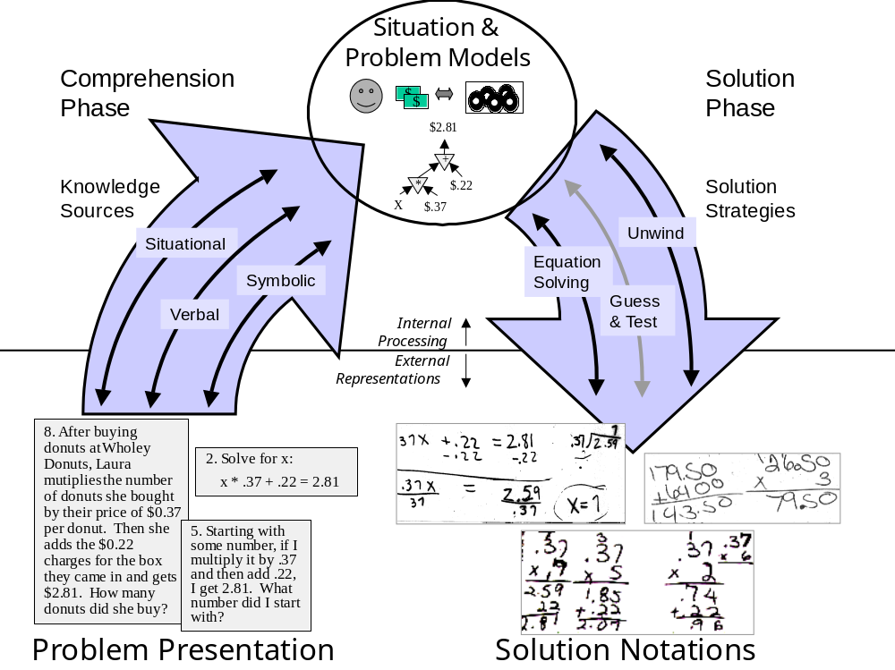

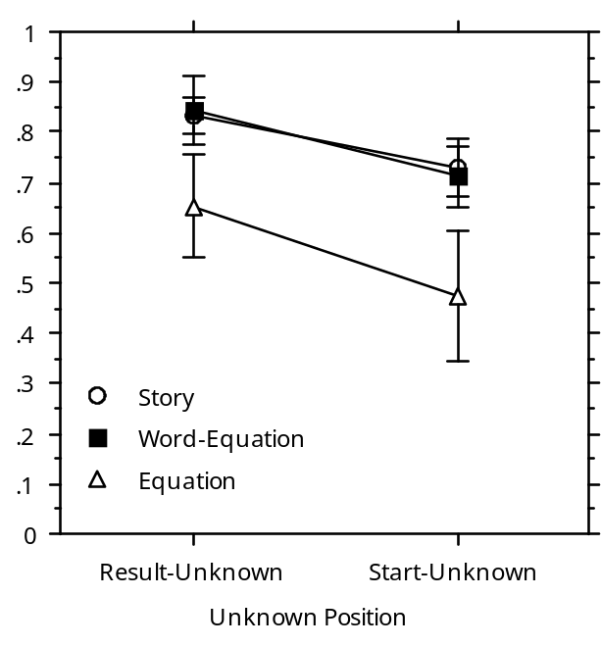
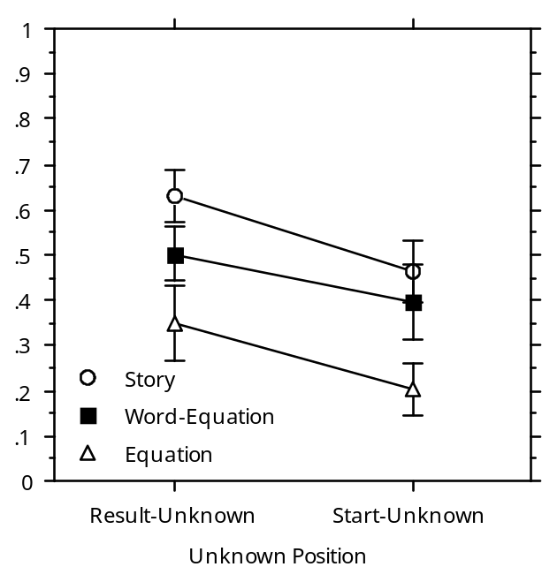
Whole Number Problems Decimal Number Problems

Figure 2. Proportion correct of high school algebra students in DFA1 (n = 76). The graphs show the effects of the three difficulty factors: representation, unknown-position, and number-type. The error bars display standard errors around the item means.

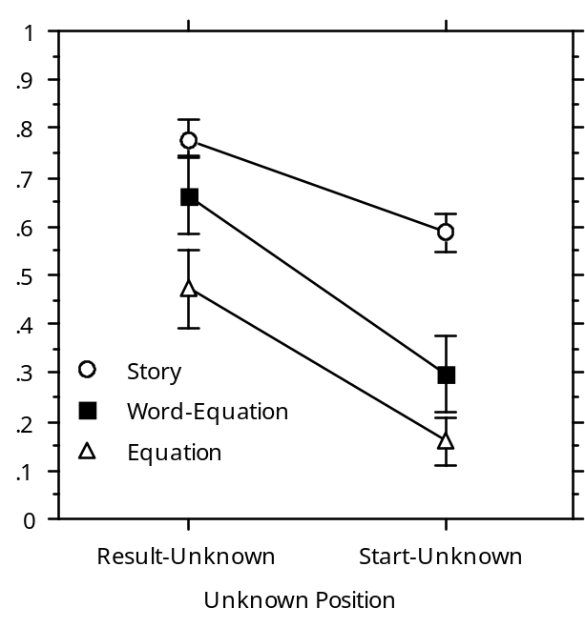
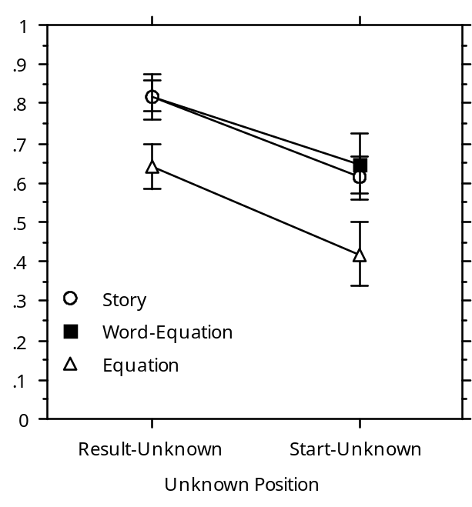
Whole Number Problems Decimal Number Problems

Figure 3. Proportion correct of high school algebra students in DFA2 (n = 171). The graphs show the effects of the three difficulty factors: representation, unknown-position, and number-type. The error bars display standard errors around the item means.

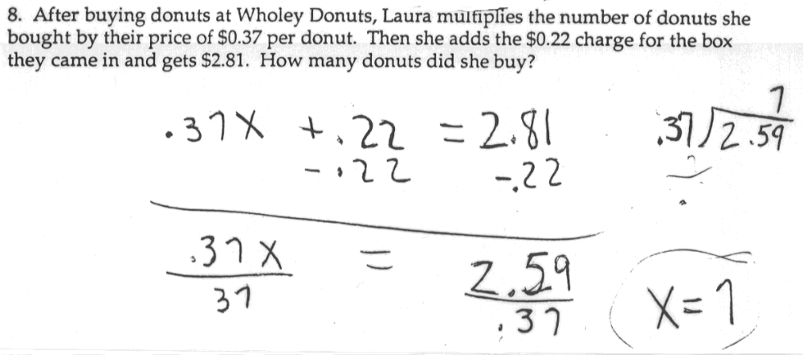
a. The normative strategy: Translate to algebra and solve algebraically

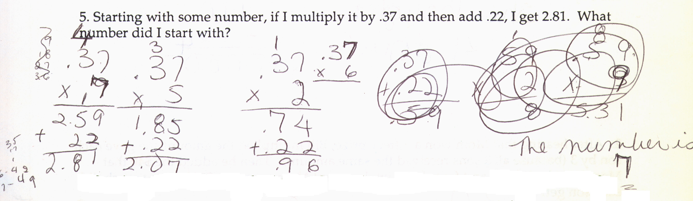
b. The guess-and-test strategy.

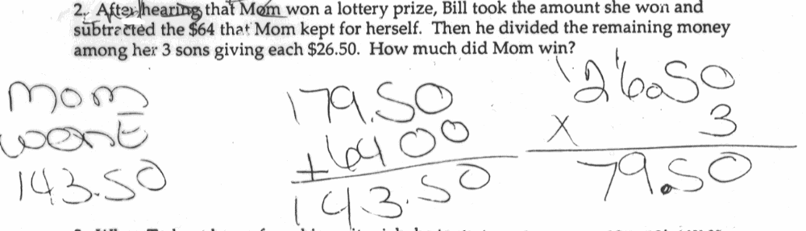
c. The unwind strategy.
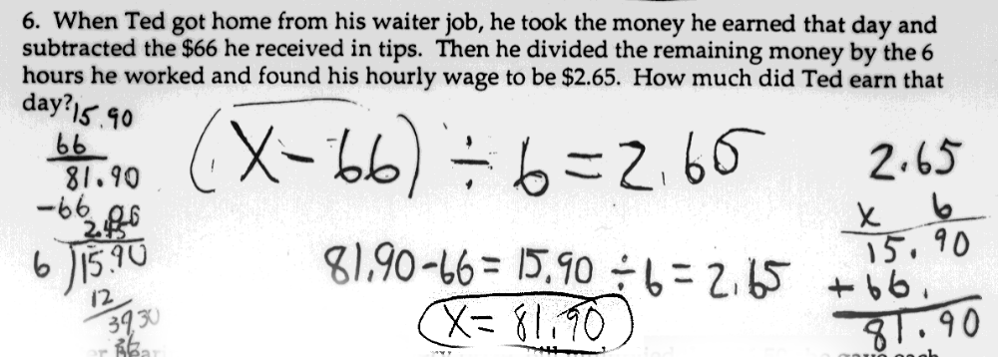
d. Translation to an algebra equation, which is then solved by the informal, unwind strategy.

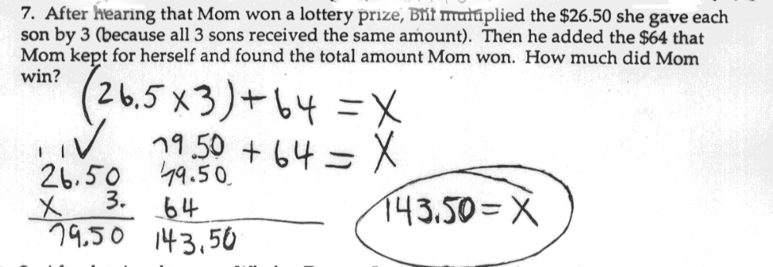
e. A rare translation of a result-unknown story to an equation.
Figure 4. Examples of successful strategies used by students: (a) Guess-and-test, (b) Unwind, (c) Translate to algebra and solve algebraically, (d) Translate to algebra and solve by unwind, (e) Translate to algebra and solve by arithmetic

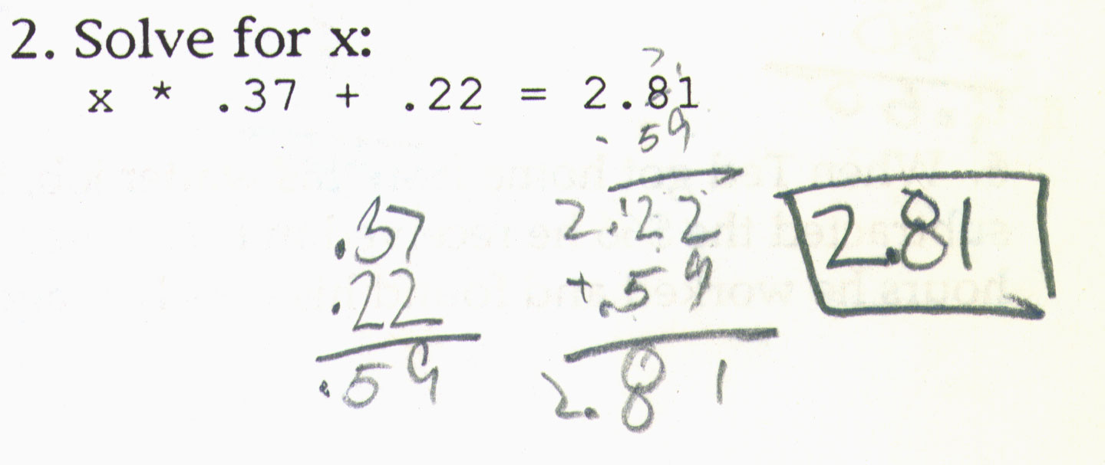
a. Order of operations error. Student inappropriately adds .37 and .22.

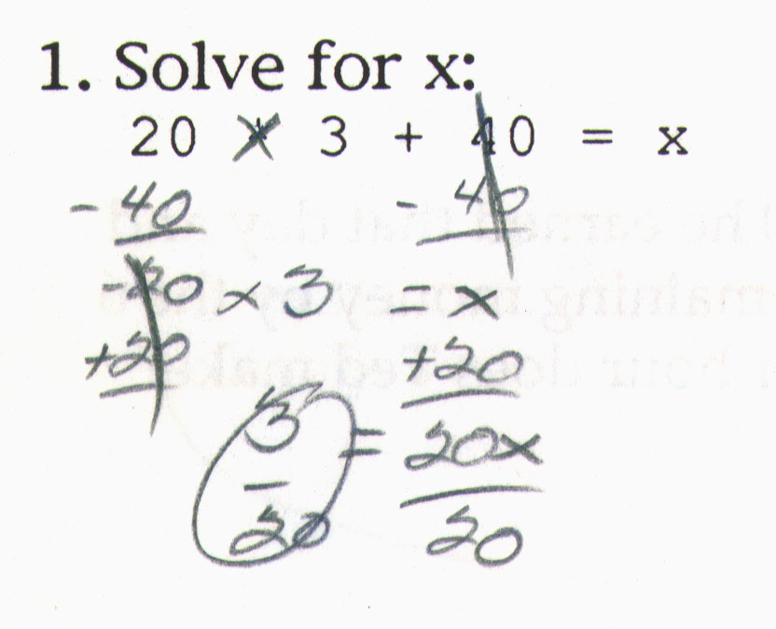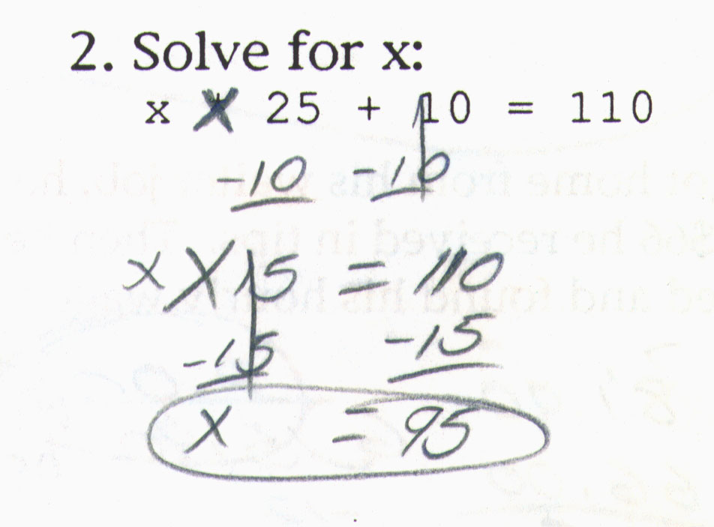
b. Algebra manipulation errors. Student subtracts from both sides of the plus sign rather than both sides of the equal sign.

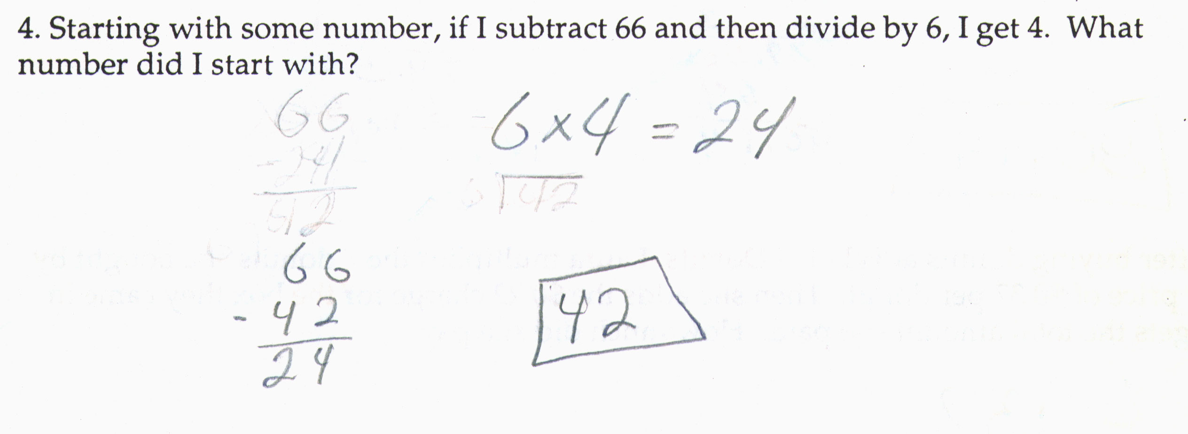
c. Argument order error . Student treats "subtract 66" (x – 66) as if it were "subtract from 66" (66 – x).
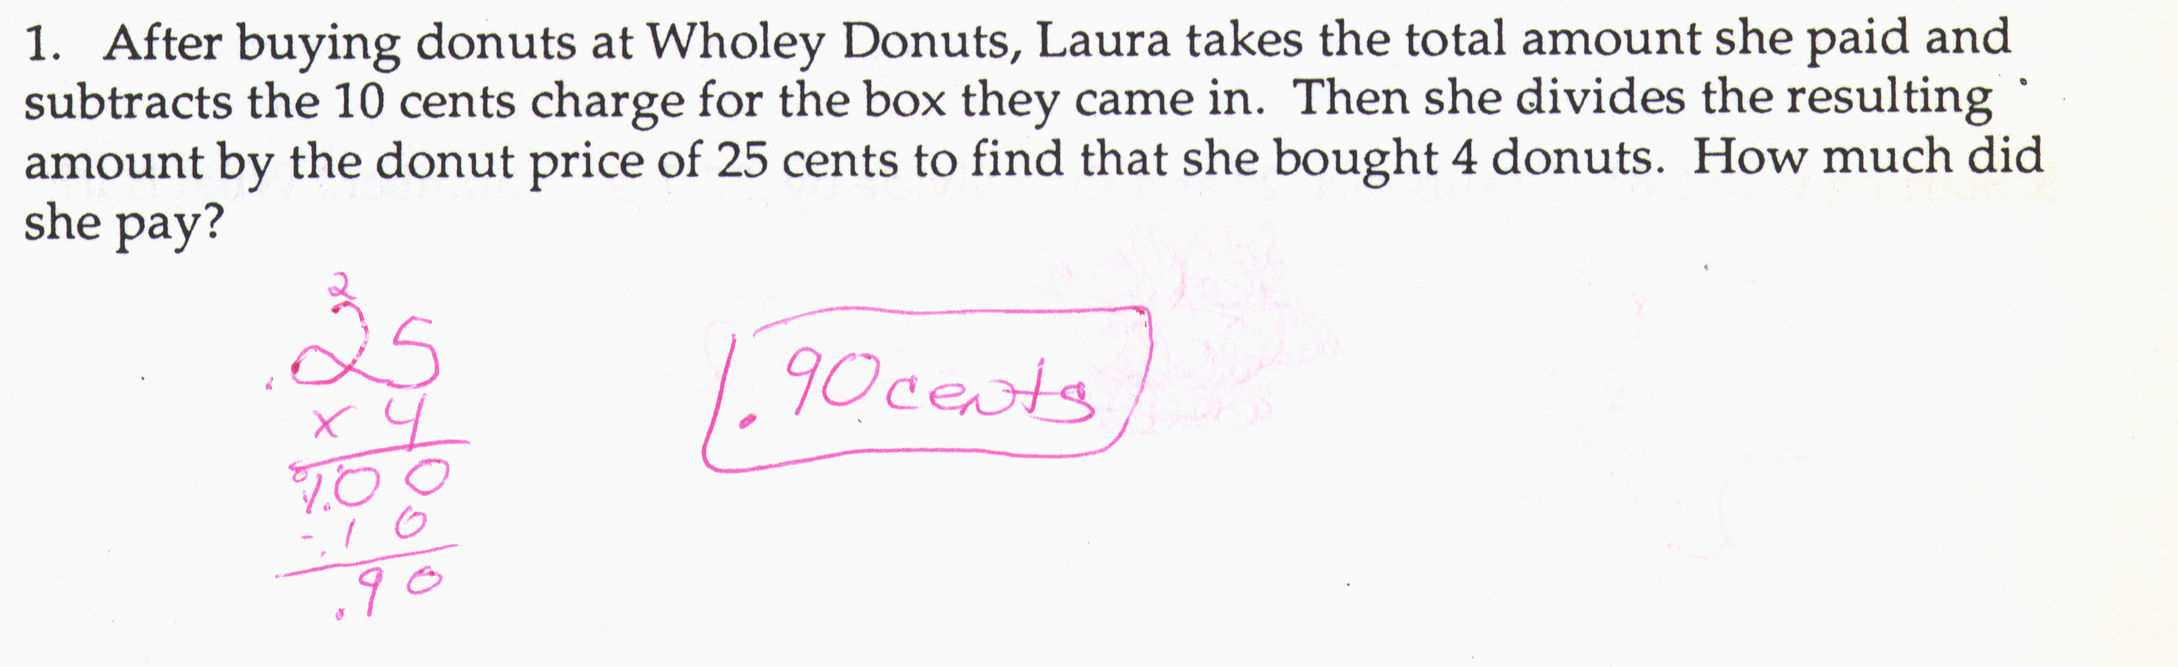
d. Inverse operator error. Student should have added .10 rather than subtracting .10.

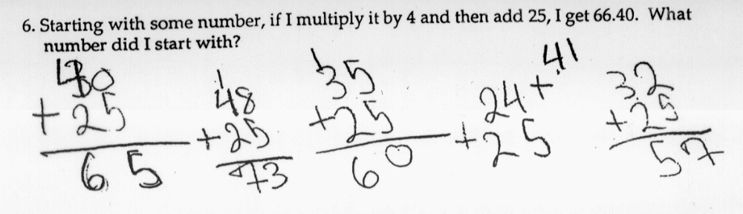
e. Incomplete guess-and-test error. Student gives up before finding a guess that works.

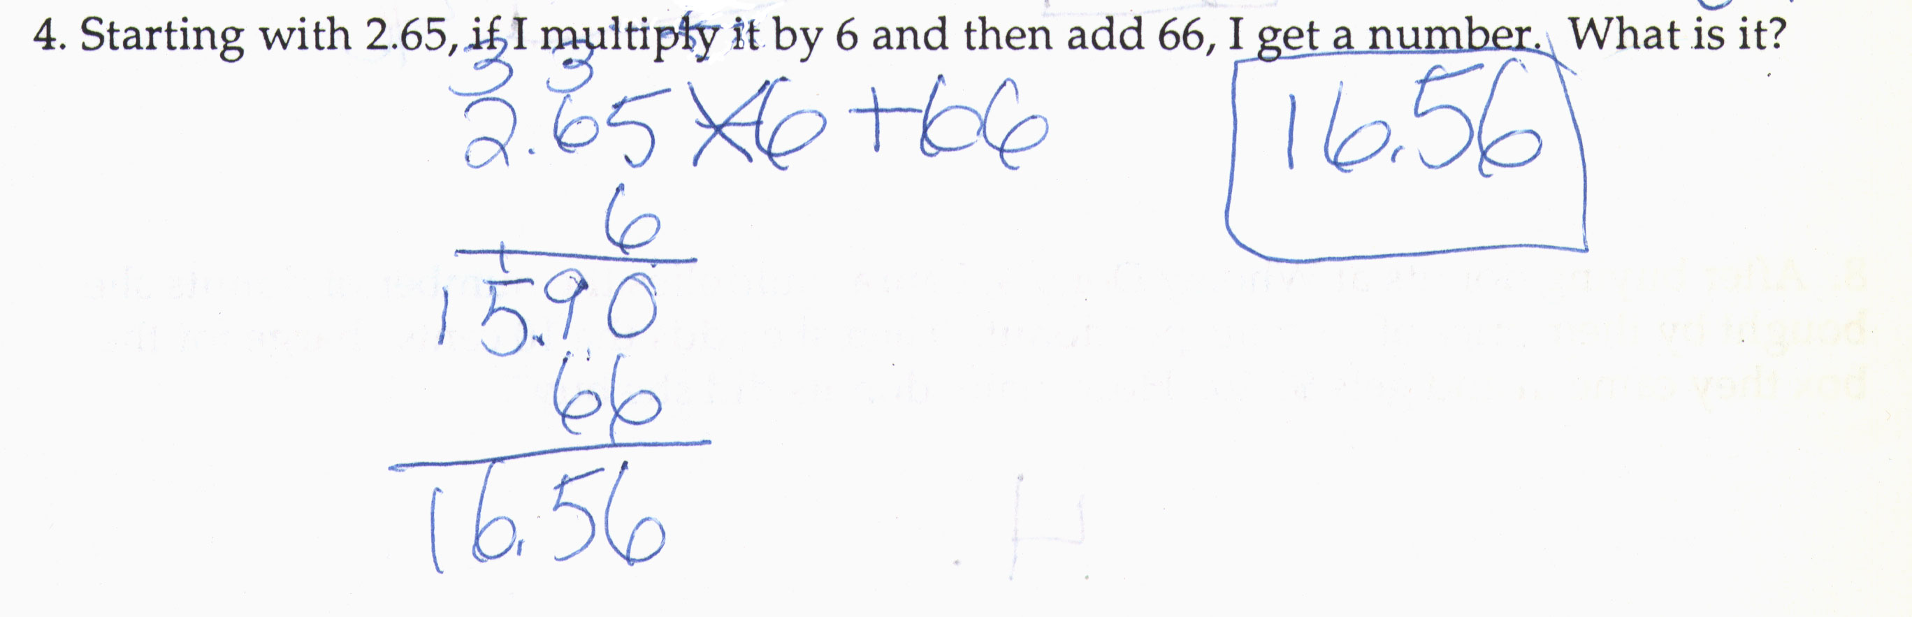
f. Decimal alignment arithmetic error. Student adds 66 to .90 aligning flush right rather than aligning place values or the decimal point.

Figure 5. Examples of errors made by students: (a) order of operations, (b) algebra manipulation, (c) argument order, (d) inverse operator, (e) incomplete guess-and-test, (f) decimal alignment arithmetic error

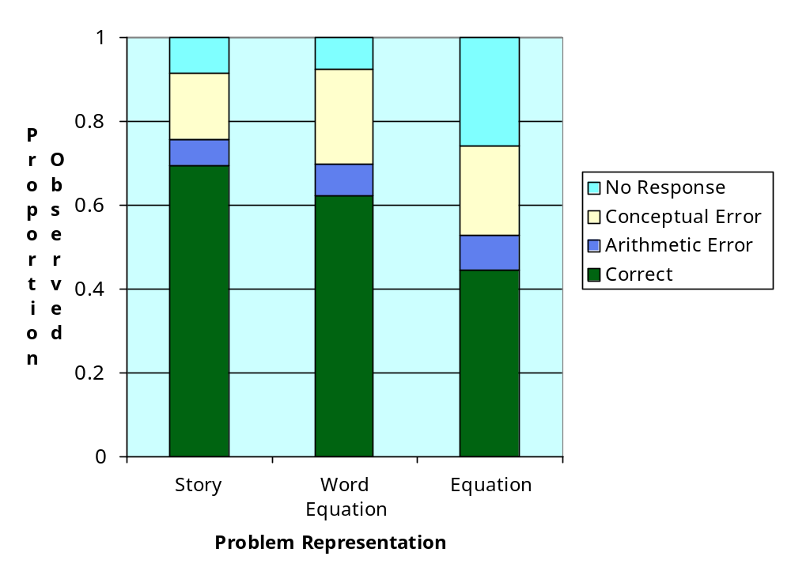(a) Proportions of correct and incorrect responses for story, word equations, and equations. A verbal facilitation is indicated particularly in the fewer no-response errors in the story and word equation problems.
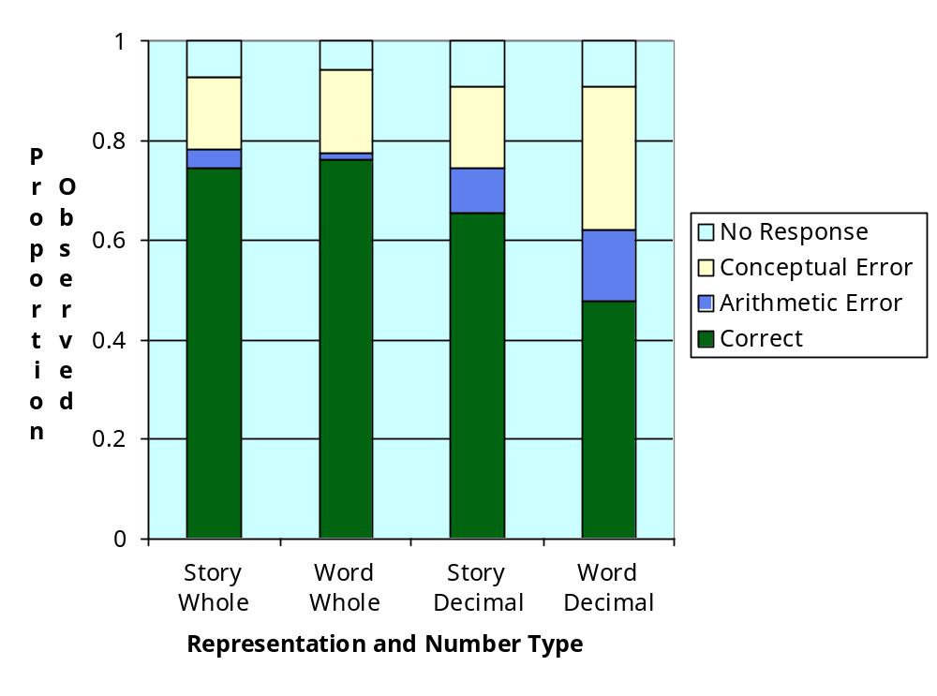
(b) Proportions of correct and incorrect responses for story vs. word equations crossed with whole vs. decimal number problems. A situation facilitation effect is indicated in decimal problems with fewer conceptual and arithmetic errors on story decimal problems than word-equation decimal problems

Figure 6. Frequency of broad error categories helps to explain the causes of the verbal and situation facilitation effects observed.

Tables

Table 1. Six Problem Categories Illustrating Two Difficulty Factors: Representation and Unknown-Position.

Story problem | Word equation | Symbolic equation
RESULT-UNKNOWN
When Ted got home from his waiter job, he took the $81.90 he earned that day and subtracted the $66 he received in tips. Then he divided the remaining money by the 6 hours he worked and found his hourly wage. How much does Ted make per hour? | Starting with 81.9, if I subtract 66 and then divide by 6, I get a number. What is it? | Solve for x:  (81.90 - 66)/6 = x
START-UNKNOWN
When Ted got home from his waiter job, he multiplied his hourly wage by the 6 hours he worked that day. Then he added the $66 he made in tips and found he had earned $81.90. How much does Ted make per hour? | Starting with some number, if I multiply it by 6 and then add 66, I get 81.9. What number did I start with? | Solve for x:  x * 6 + 66 = 81.90

Table 2. Examples of the Four Cover Stories Used.

Story Problem Cover Stories
DONUT | LOTTERY | WAITER | BASKETBALL
After buying donuts at Wholey Donuts, Laura multiplies the 7 donuts she bought by their price of $0.37 per donut. Then she adds the $0.22 charge for the box they came in and gets the total amount she paid. How much did she pay? | After hearing that Mom won a lottery prize, Bill took the $143.50 she won and subtracted the $64 that Mom kept for herself. Then he divided the remaining money among her 3 sons giving each the same amount. How much did each son get? | When Ted got home from his waiter job, he multiplied his wage of $2.65 per hour by the 6 hours he worked that day. Then he added the $66 he made in tips and found how much he earned. How much did Ted earn that day? | After buying a basketball with his daughters, Mr. Jordan took the price of the ball, $68.36, and subtracted the $25 he contributed. Then he divided the rest by 4 to find out what each daughter paid. How much did each daughter pay?

Table 3. Difficulty Factor Space and Distribution of Problems on Forms
Number type -> |  |  | Integer |  |  |  | Decimal
Cover story -> |  |  | Donut | Lottery | Waiter | Bball | Donut | Lottery | Waiter | Bball
Base equation -> |  |  | 4*25+10  = 110 | 20*3+40  = 100 | 4*6 + 66  = 90 | 3*5 + 34  = 49 | 7 * .37  + .22  = 2.81 | 26.50* 3  + 64  = 143.50 | 2.65* 6  + 66  = 81.90 | 10.84*4  + 25  = 68.36
Presenta-tion | Unk. posit. | Final arith
story | result | *, + |  |  |  |  | 1.1
story | result | -, / |  |  |  |  |  |  | 1.3
story | start | *, + |  |  |  |  |  |  |  | 1.4
story | start | -, / |  |  |  |  |  | 1.2
word-eq | result | *, +
word-eq | result | -, / |  | 1.6
word-eq | start | *, +
word-eq | start | -, / | 1.5
equation | result | *, + |  |  |  | 1.8
equation | result | -, /
equation | start | *, + |  |  | 1.7
equation | start | -, /

Table 4. Solution strategies (%'s) employed by solvers as a function of problem representation for start-unknown problems.

Problem representation | Unwind | Guess & Test | Symbol Manipulation | No Response | Answer Only | Unknown | Total
Story | 50 | 7 | 5 | 12 | 18 | 8 | 100
Word equation | 22 | 23 | 11 | 13 | 19 | 12 | 100
Equation | 13 | 14 | 22 | 32 | 11 | 8 | 100

Table 5. Likelihood that strategies used by students on start-unknown problems leads to a correct answer.

Strategies | No. correct / no. attempted | Likelihood strategy leads to correct answer
Unwind | 232 /335 | 69%
Guess & Test | 89 / 125 | 71%
Symbol Manipulation | 56 / 109 | 51%
Answer Only | 90/ 161 | 56%
Unknown | 38/ 89 | 43%
Total with Response | 505 / 819 | 62%
No Response | 0 / 169 | 0%
Total | 505 / 988 | 51%

Recent reviews of mathematics learning research (Kilpatrick, Swafford, Findell, 2001), story problem research (Reed, 1998) and algebra research (Bednarz, Kieran, Lee, 1996; Kieran, 1992) do not reference any such studies.
Combinations of the symbolic, situation, and verbal facilitation hypotheses are possible. For instance, combining symbolic and situation facilitation predicts that story problems and equations will both be easier than word equations. Alternatively, combining situation and verbal facilitation predicts that story problems will be easier than word equations and, in turn, word equations will be easier than equations.
Because the dependent variable is a proportion (students solving the item correctly divided by the number of students who saw the item) we used a logit transformation as recommended by Cohen & Cohen (1973, pp. 254-259): .5 * ln(p / (1-p)) where p=0 is replaced by p=1/(2N) and p=1 by p=1-1/(2N) and N is number of students who see the item. Note, analyses using the proportions without transformation yield quite similar results and do not move any p-values across the 0.05 threshold.
The proportion of conceptual errors reported here is conditional on there having been a response -- solutions with no response errors are not counted in the denominator.
The proportion of arithmetic errors reported here is conditional on the solution being conceptually correct -- solutions with no response or conceptual errors are not counted in the denominator.

